**Reg. No. 21BCE1297 Name: Vidhi Shah Date of Practical: 18/04/22 & 25/04/22**

**Experiment 9**

**Aim:**

To simulate and verify basic Logic Gates and Boolean Functions.

**Tools and Apparatus:**

DC Voltage Source, AND, NAND, OR, NOR, NOT, XOR and XNOR gates.

**Theory:**

**Truth Tables:**

|  |  |  |  |  |  |  |  |
| --- | --- | --- | --- | --- | --- | --- | --- |
| **Input** | | **Output** | | | | | |
| **A** | **B** | **AND** | **NAND** | **OR** | **NOR** | **XOR** | **XNOR** |
| 0 | 0 | 0 | 1 | 0 | 1 | 0 | 1 |
| 0 | 1 | 0 | 1 | 1 | 0 | 1 | 0 |
| 1 | 0 | 0 | 1 | 1 | 0 | 1 | 0 |
| 1 | 1 | 1 | 0 | 1 | 0 | 0 | 1 |

|  |  |
| --- | --- |
| **Input** | **Output** |
| **X** | **NOT** |
| 0 | 1 |
| 1 | 0 |

|  |  |  |  |  |
| --- | --- | --- | --- | --- |
| **Input** | | | | **Output** |
| **A** | **B** | **C** | **D** |  |
| 0 | 1 | 0 | 1 | 1 |
| 0 | 0 | 1 | 1 | 1 |
| 1 | 1 | 1 | 0 | 0 |
| 1 | 0 | 1 | 1 | 1 |
| 1 | 1 | 0 | 1 | 0 |
| 0 | 1 | 1 | 1 | 1 |
| 1 | 1 | 1 | 1 | 0 |



|  |  |  |  |  |
| --- | --- | --- | --- | --- |
| **Input** | | | | **Output** |
| **A** | **B** | **C** | **D** |  |
| 0 | 0 | 0 | 0 | 1 |
| 0 | 0 | 0 | 1 | 1 |
| 0 | 0 | 1 | 0 | 1 |
| 0 | 1 | 0 | 0 | 1 |
| 1 | 0 | 0 | 0 | 1 |
| 1 | 1 | 0 | 0 | 1 |
| 1 | 0 | 1 | 0 | 1 |
| 1 | 0 | 0 | 1 | 1 |
| 0 | 1 | 1 | 0 | 1 |

|  |  |  |  |
| --- | --- | --- | --- |
| **Input** | | | **Output** |
| **A** | **B** | **C** |  |
| 0 | 0 | 0 | 0 |
| 1 | 0 | 0 | 0 |
| 0 | 1 | 0 | 1 |
| 0 | 0 | 1 | 0 |
| 1 | 1 | 0 | 1 |
| 1 | 0 | 1 | 1 |
| 0 | 1 | 1 | 1 |
| 1 | 1 | 1 | 1 |

|  |  |  |  |  |  |
| --- | --- | --- | --- | --- | --- |
| **Input** | | | |  | **Output** |
| **A** | **B** | **C** | **D** | **E** |  |
| 1 | 0 | 0 | 1 | 1 | 0 |
| 0 | 1 | 1 | 1 | 0 | 0 |
| 0 | 1 | 1 | 0 | 1 | 0 |
| 0 | 1 | 0 | 1 | 1 | 0 |
| 0 | 0 | 1 | 1 | 1 | 1 |
| 1 | 1 | 1 | 1 | 0 | 0 |
| 1 | 1 | 1 | 0 | 1 | 0 |
| 1 | 1 | 0 | 1 | 1 | 0 |
| 1 | 0 | 1 | 1 | 1 | 0 |
| 0 | 1 | 1 | 1 | 1 | 0 |
| 1 | 1 | 1 | 1 | 1 | 0 |

|  |  |  |  |  |  |
| --- | --- | --- | --- | --- | --- |
| **Input** | | | | | **Output** |
| **A** | **B** | **C** | **D** | **E** |  |
| 0 | 0 | 0 | 0 | 0 | 1 |
| 1 | 0 | 0 | 0 | 0 | 0 |
| 0 | 1 | 0 | 0 | 0 | 0 |
| 0 | 0 | 1 | 0 | 0 | 1 |
| 0 | 0 | 0 | 1 | 0 | 0 |
| 0 | 0 | 0 | 0 | 1 | 1 |
| 1 | 1 | 0 | 0 | 0 | 0 |
| 1 | 0 | 1 | 0 | 0 | 1 |
| 1 | 0 | 0 | 1 | 0 | 0 |
| 1 | 0 | 0 | 0 | 1 | 0 |
| 0 | 1 | 1 | 0 | 0 | 0 |
| 0 | 1 | 0 | 1 | 0 | 0 |
| 0 | 1 | 0 | 0 | 1 | 0 |
| 0 | 0 | 1 | 1 | 0 | 1 |
| 0 | 0 | 1 | 0 | 1 | 1 |
| 0 | 0 | 0 | 1 | 1 | 1 |
| 1 | 1 | 1 | 0 | 0 | 0 |
| 1 | 1 | 0 | 1 | 0 | 0 |
| 1 | 1 | 0 | 0 | 1 | 0 |
| 1 | 0 | 1 | 1 | 0 | 0 |
| 1 | 0 | 1 | 0 | 1 | 1 |

**Simulation Results:**

1. **AND Gate**

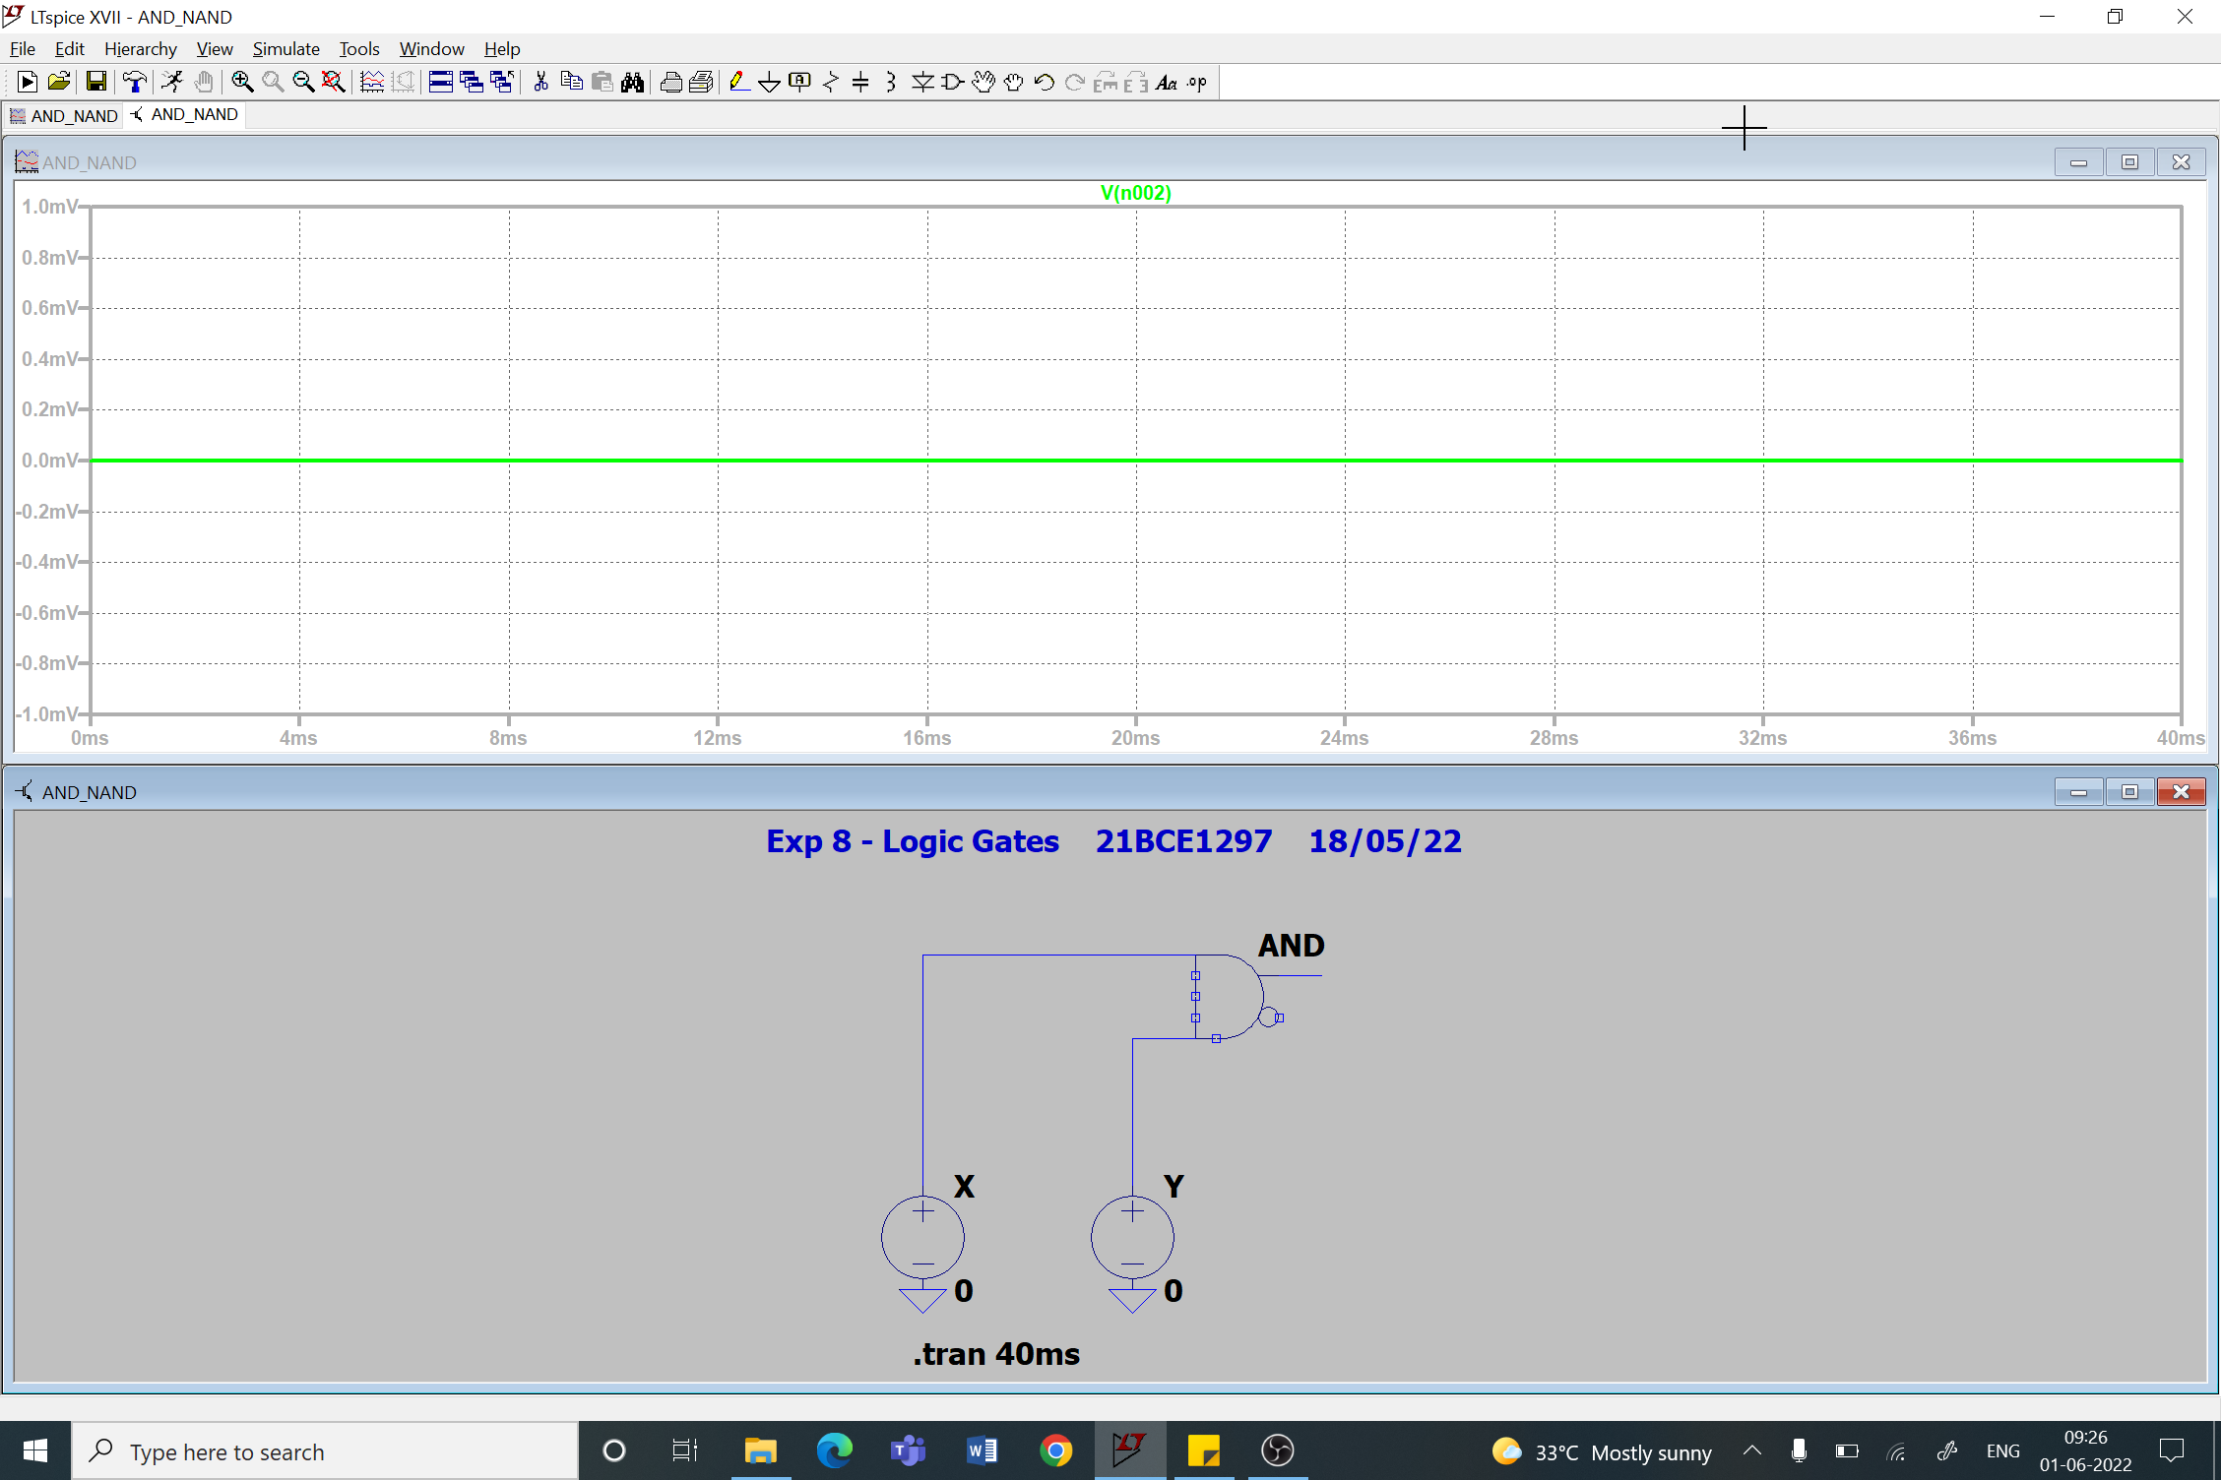

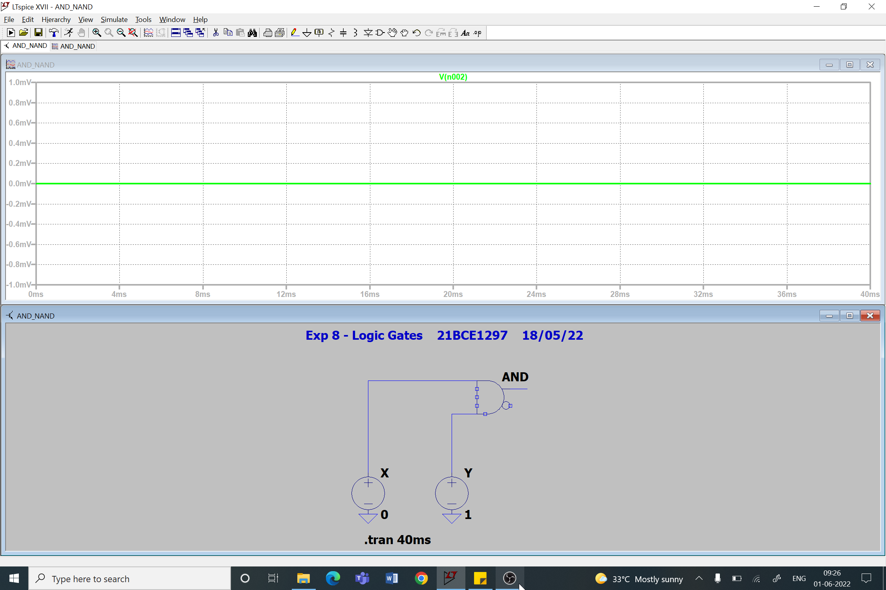

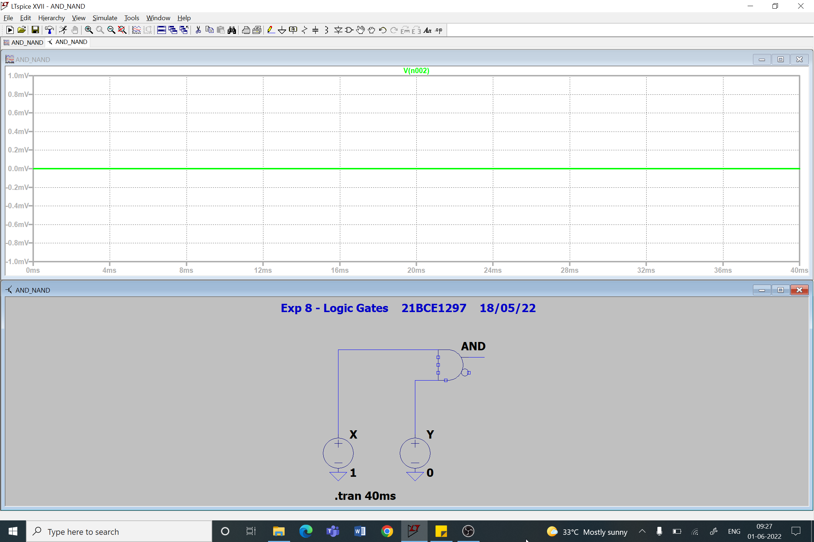

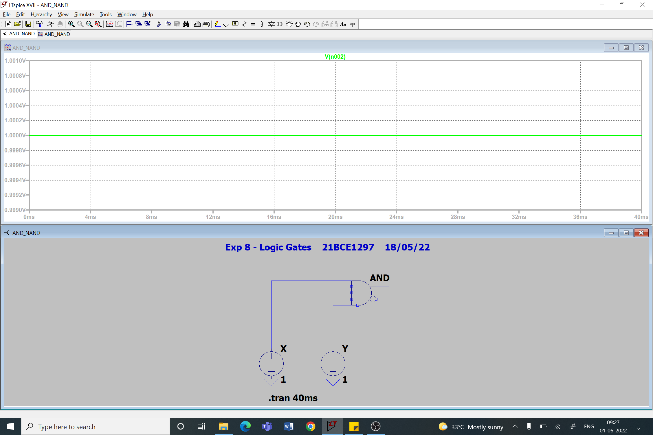

1. **NAND Gate**

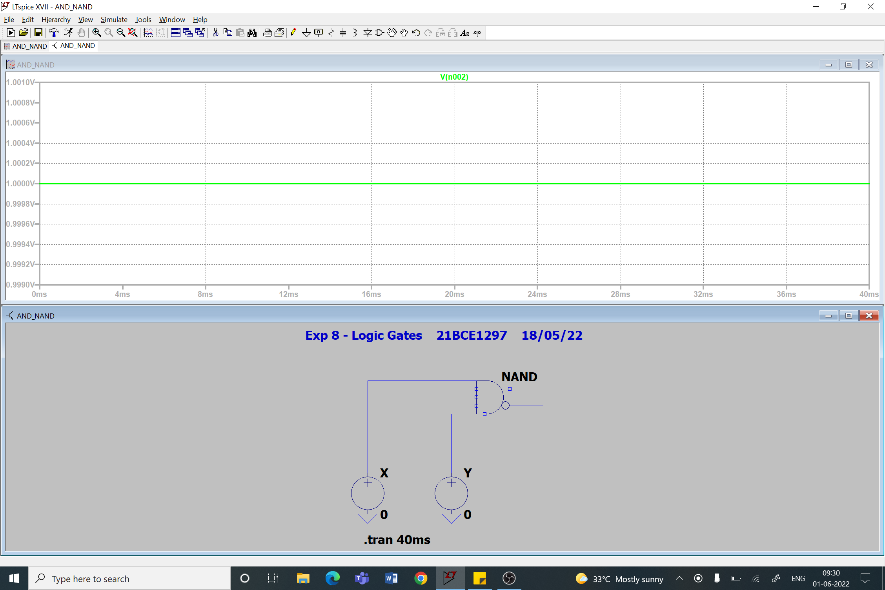

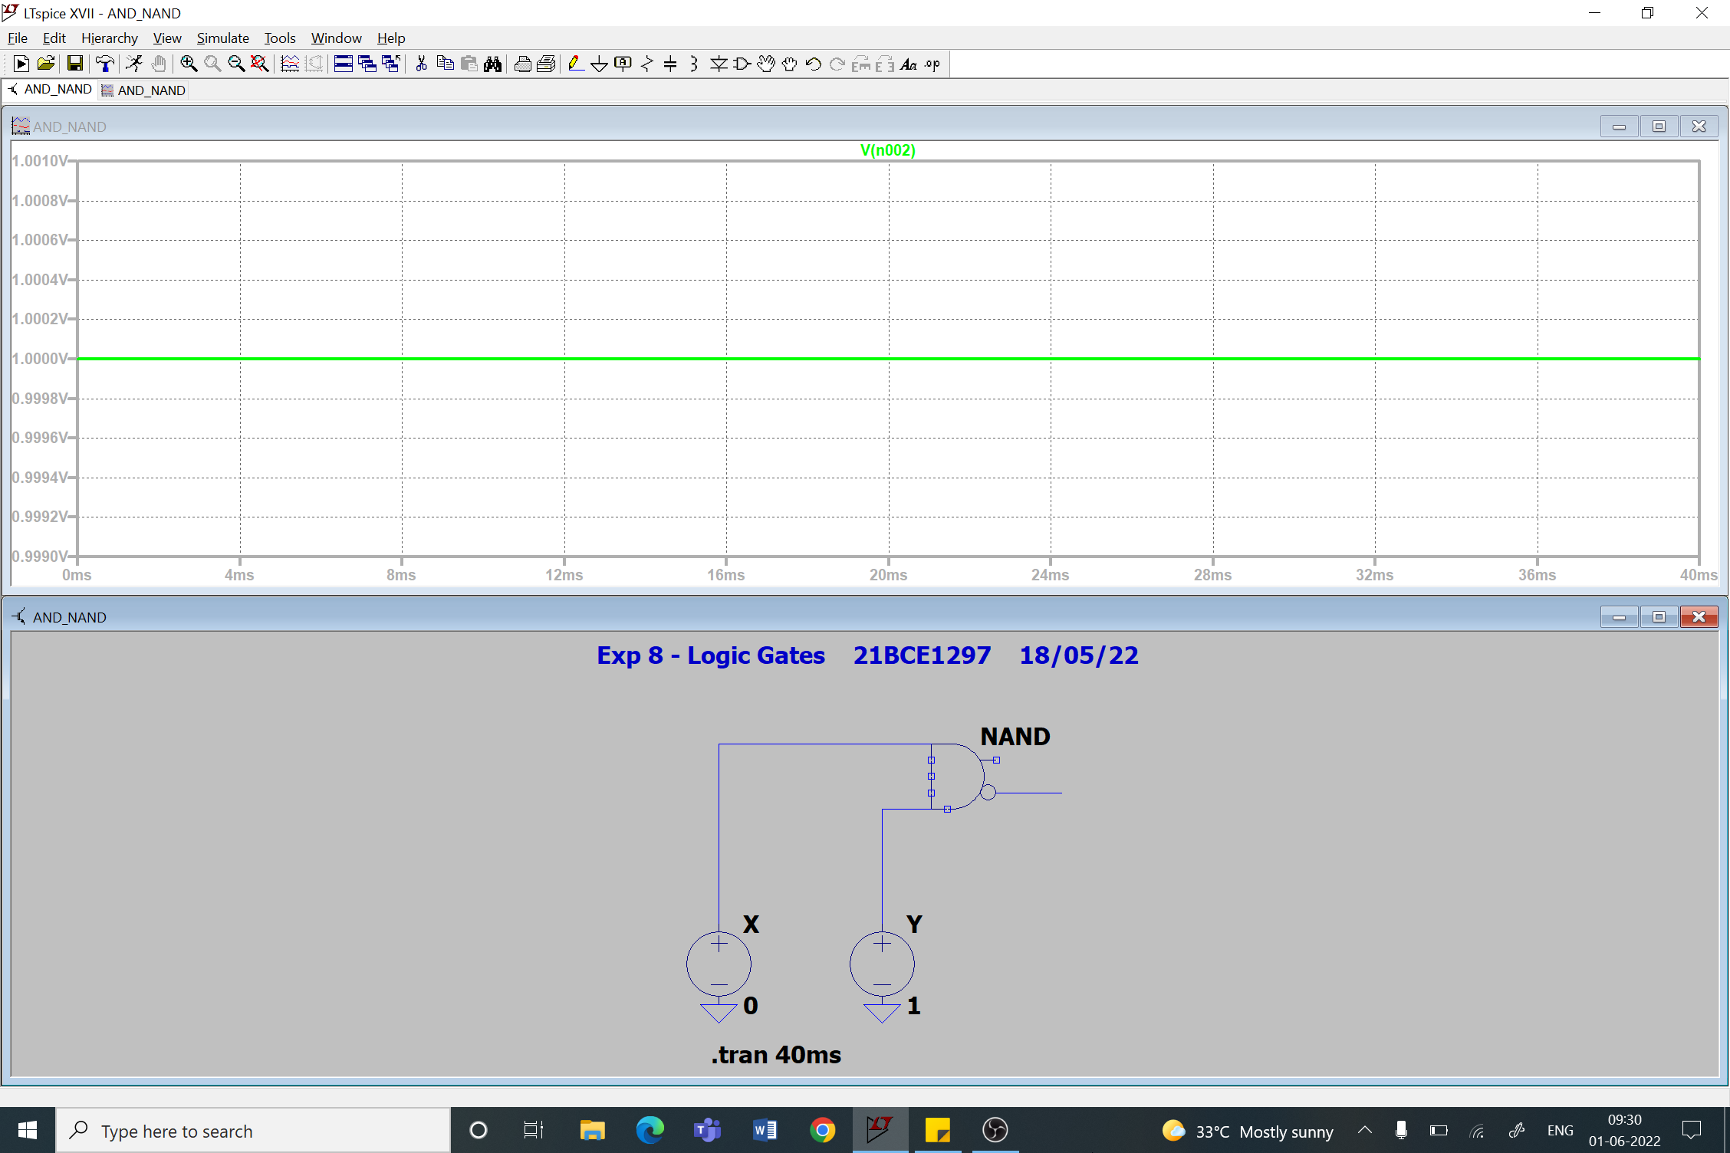

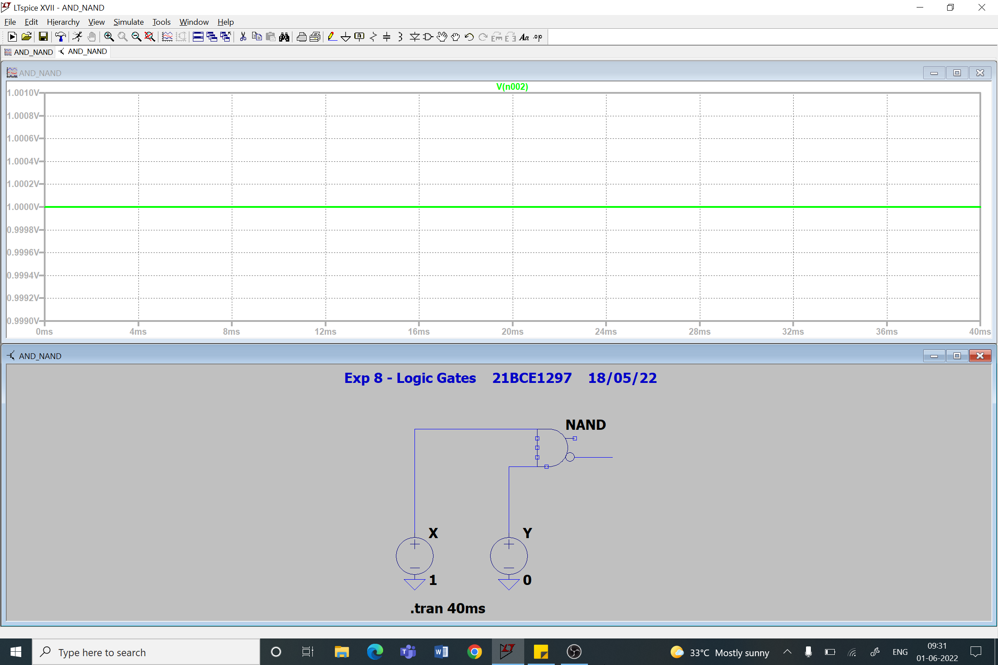

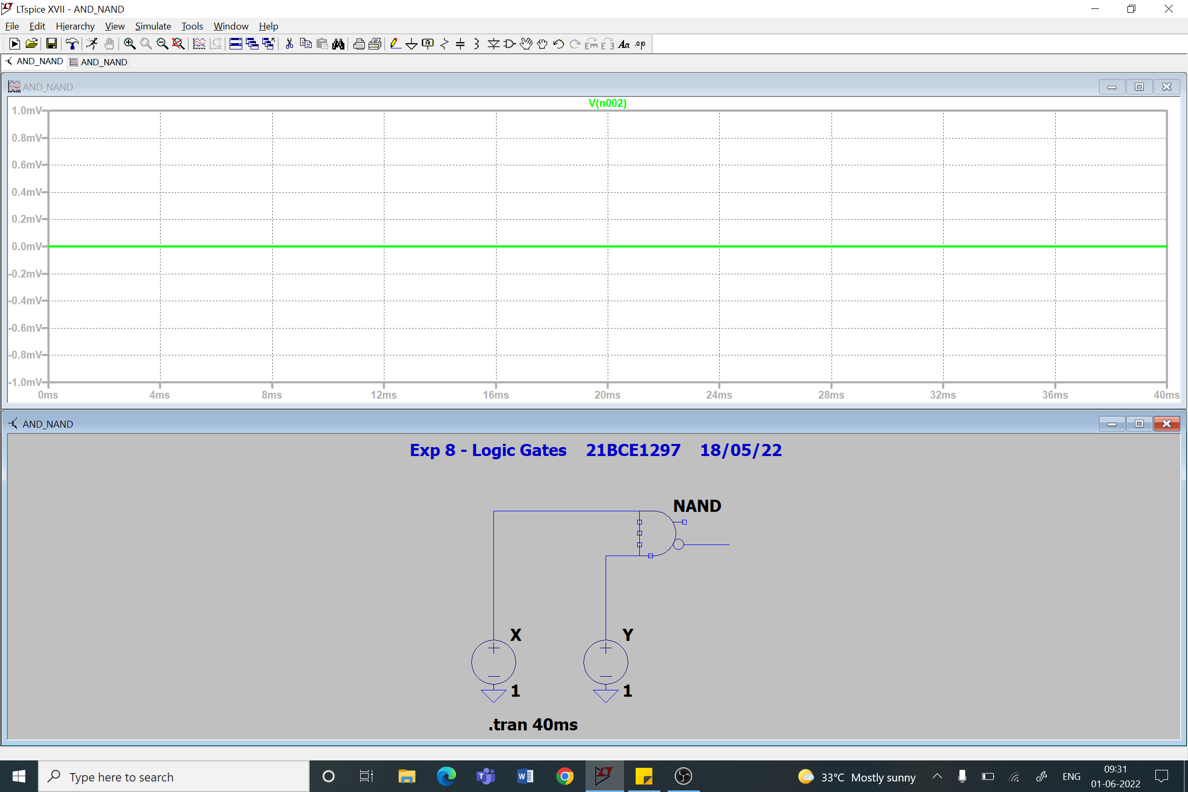

1. **OR Gate**

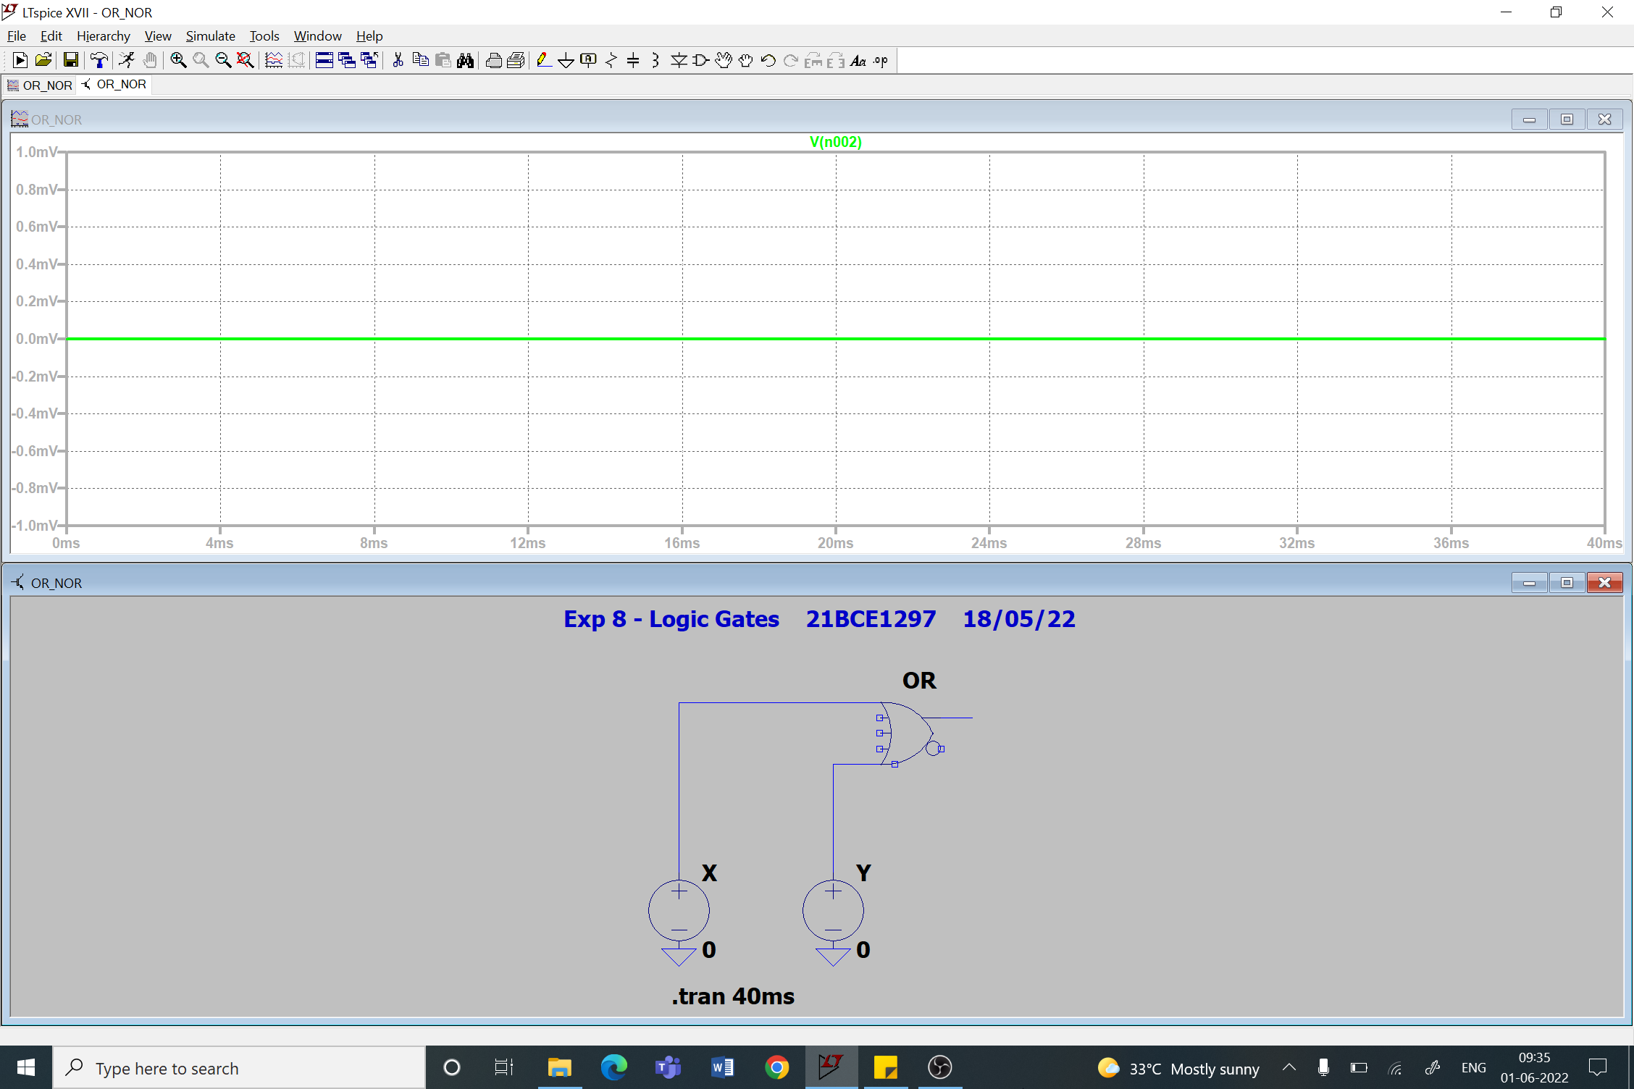

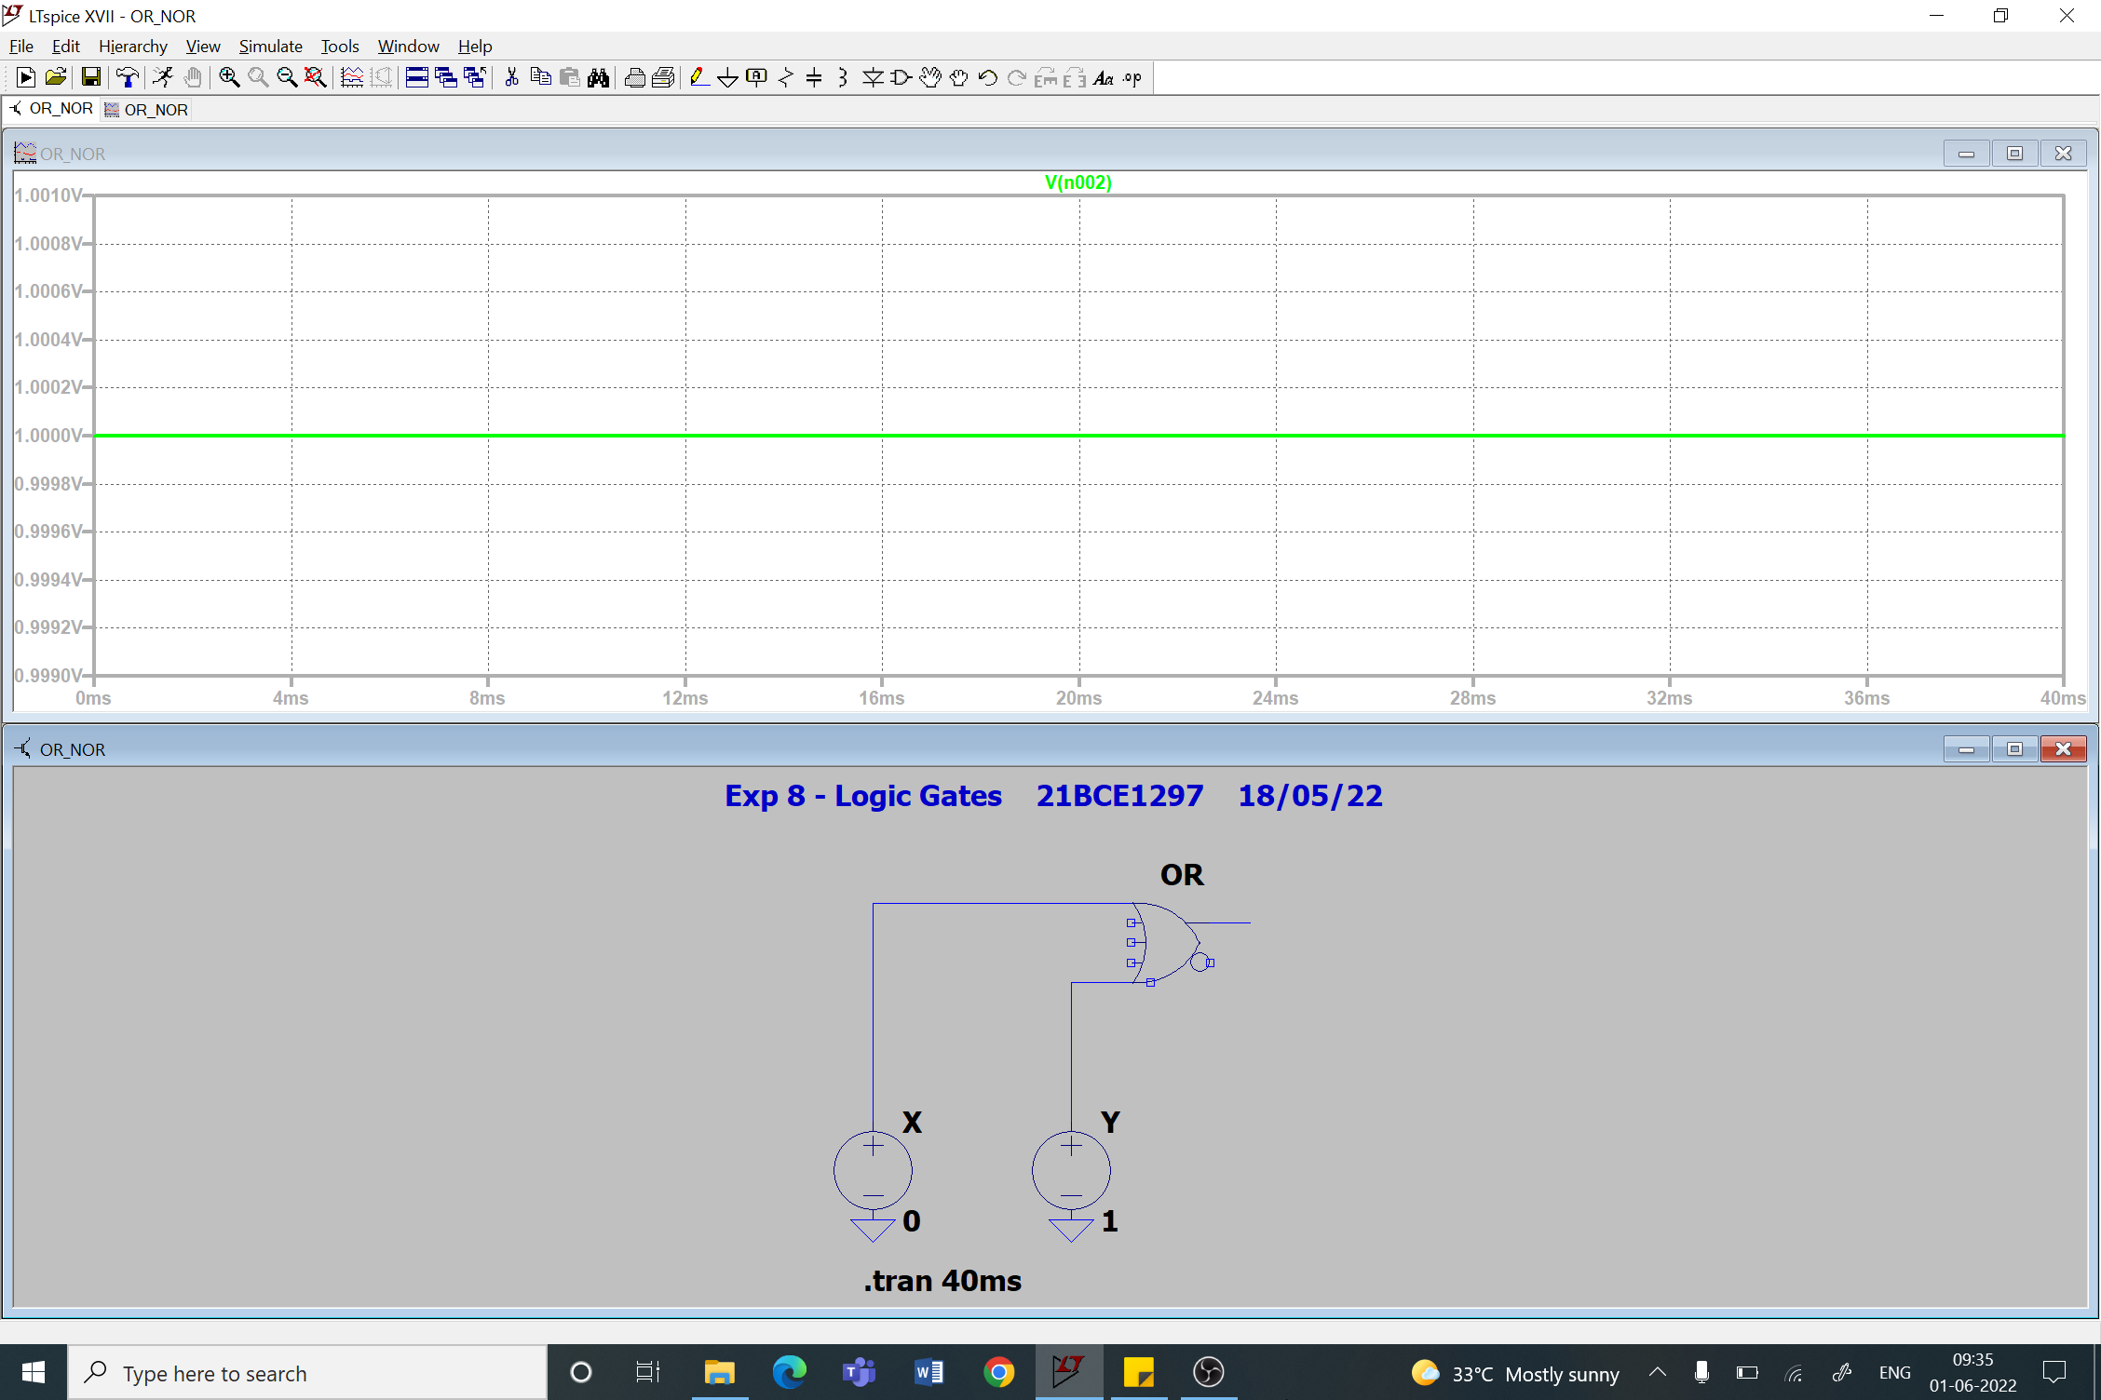

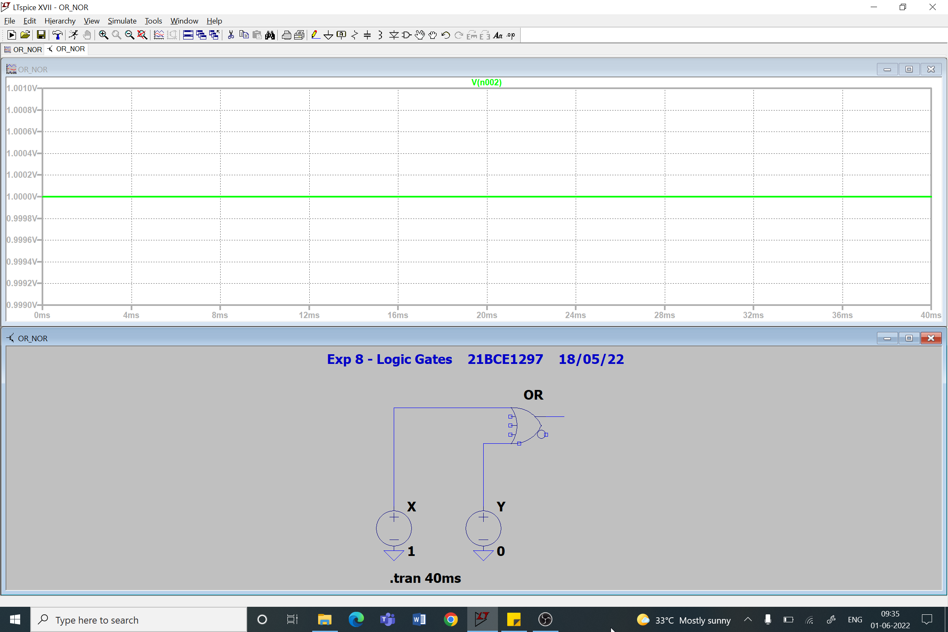

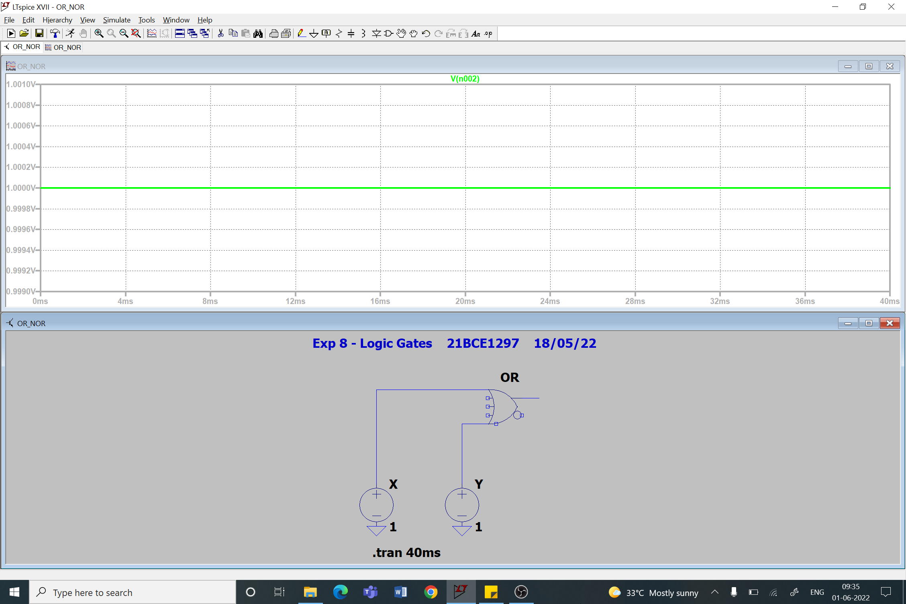

1. **NOR Gate**

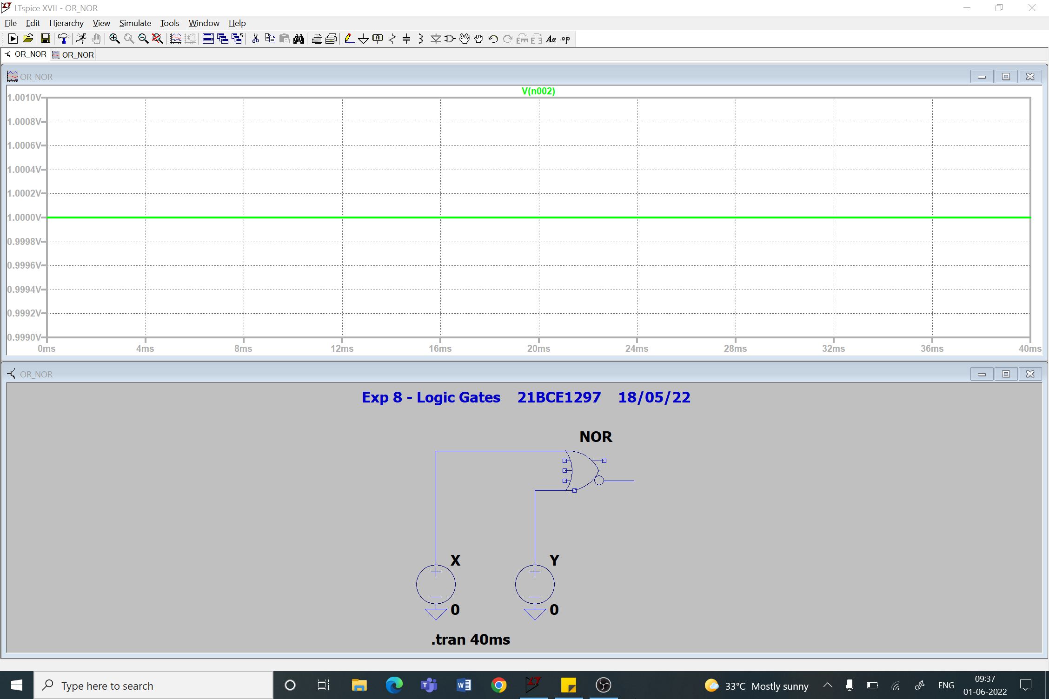

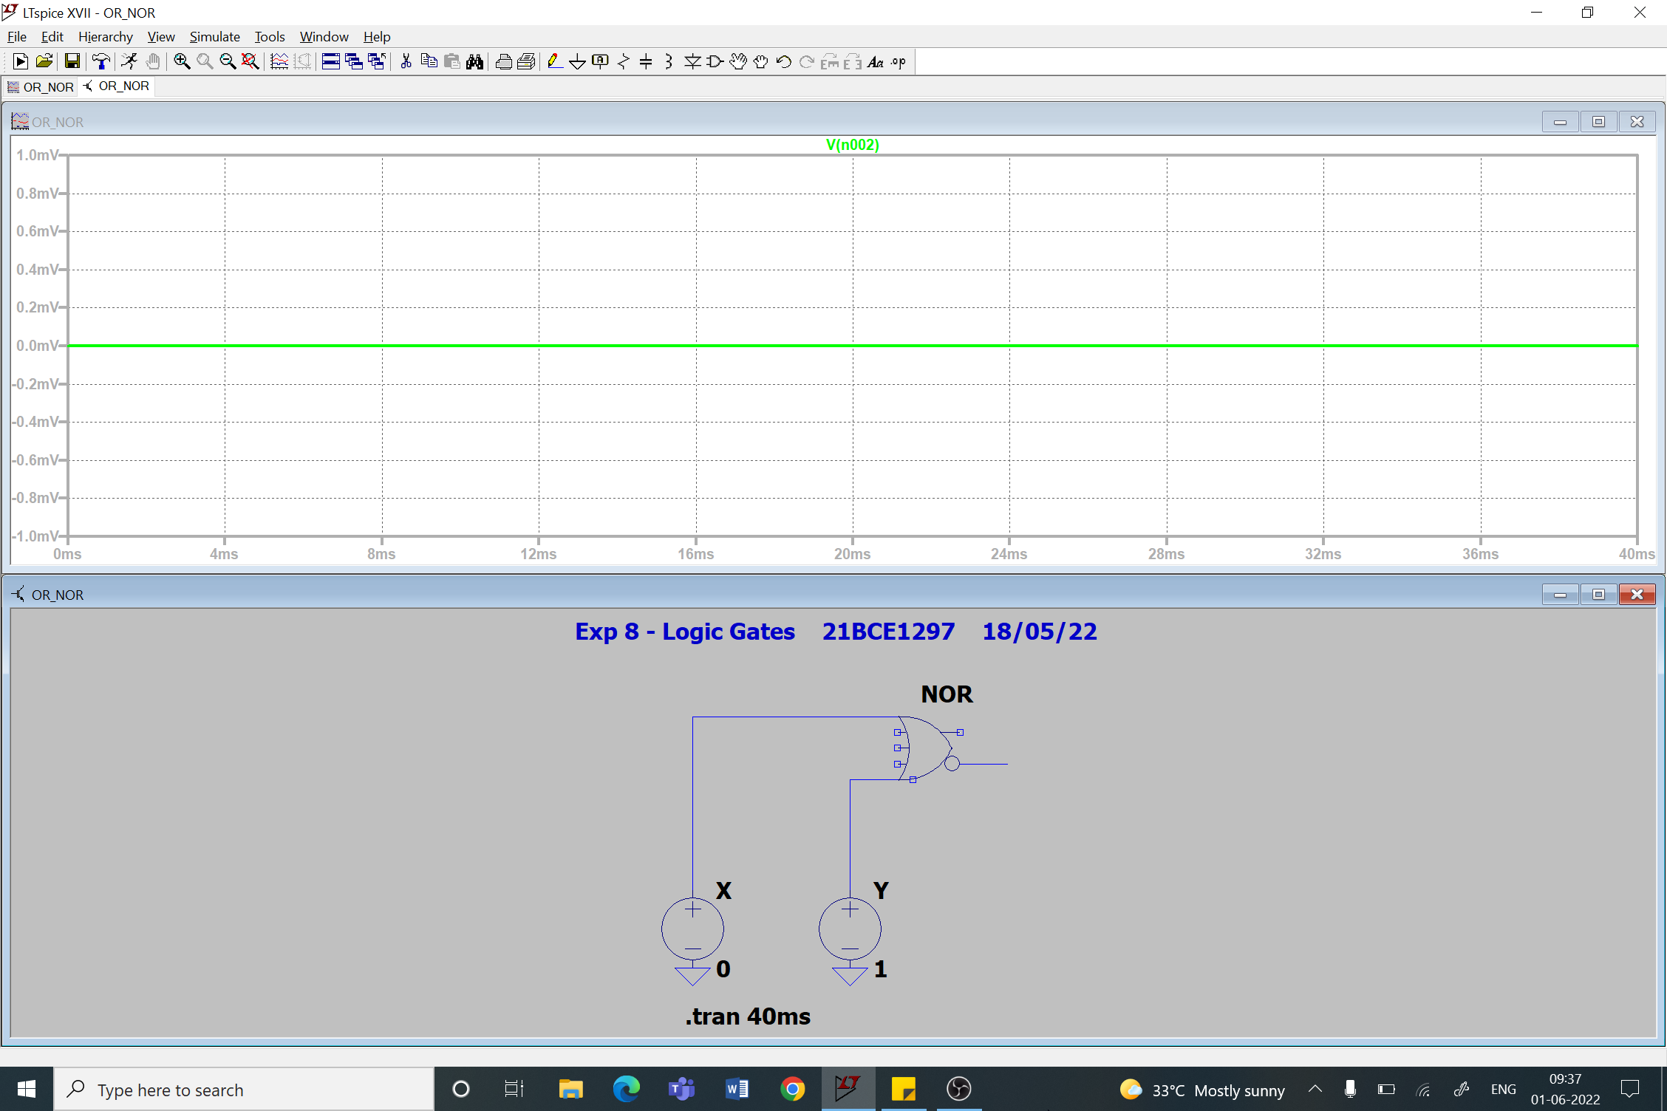

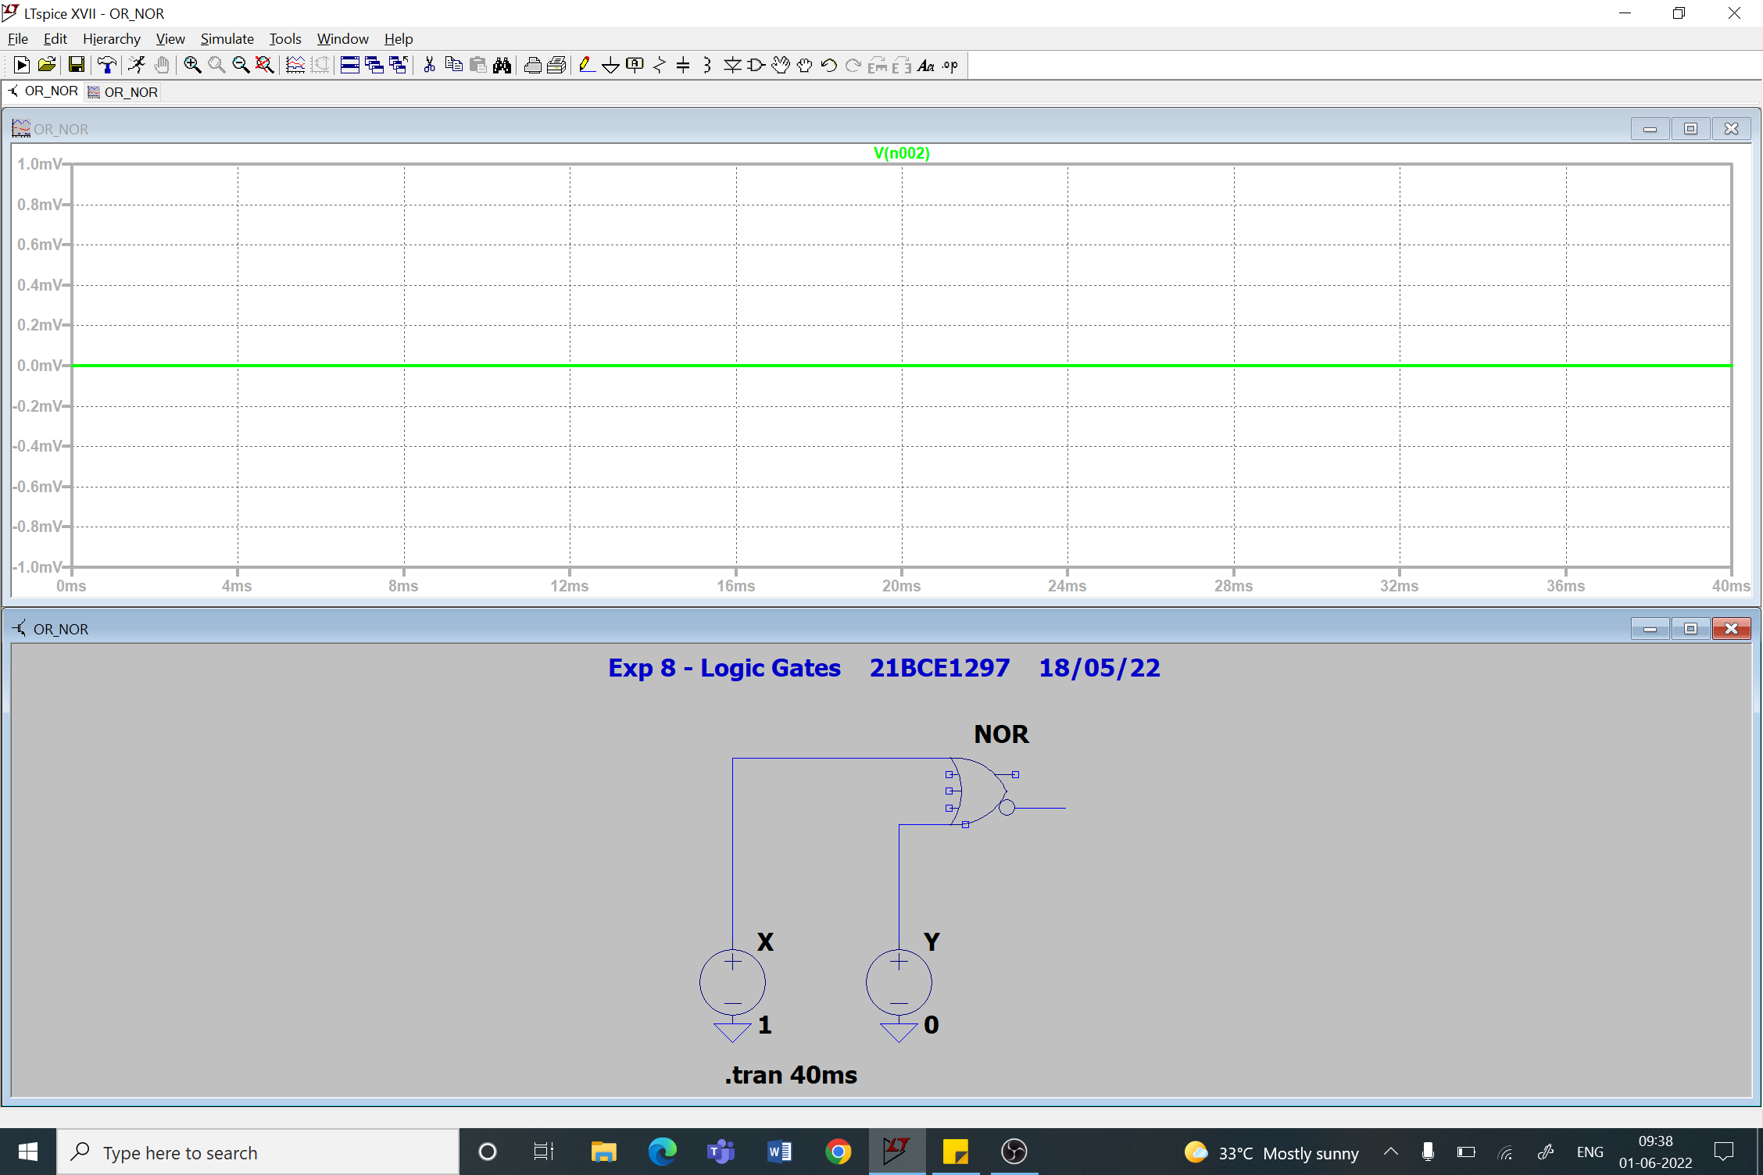

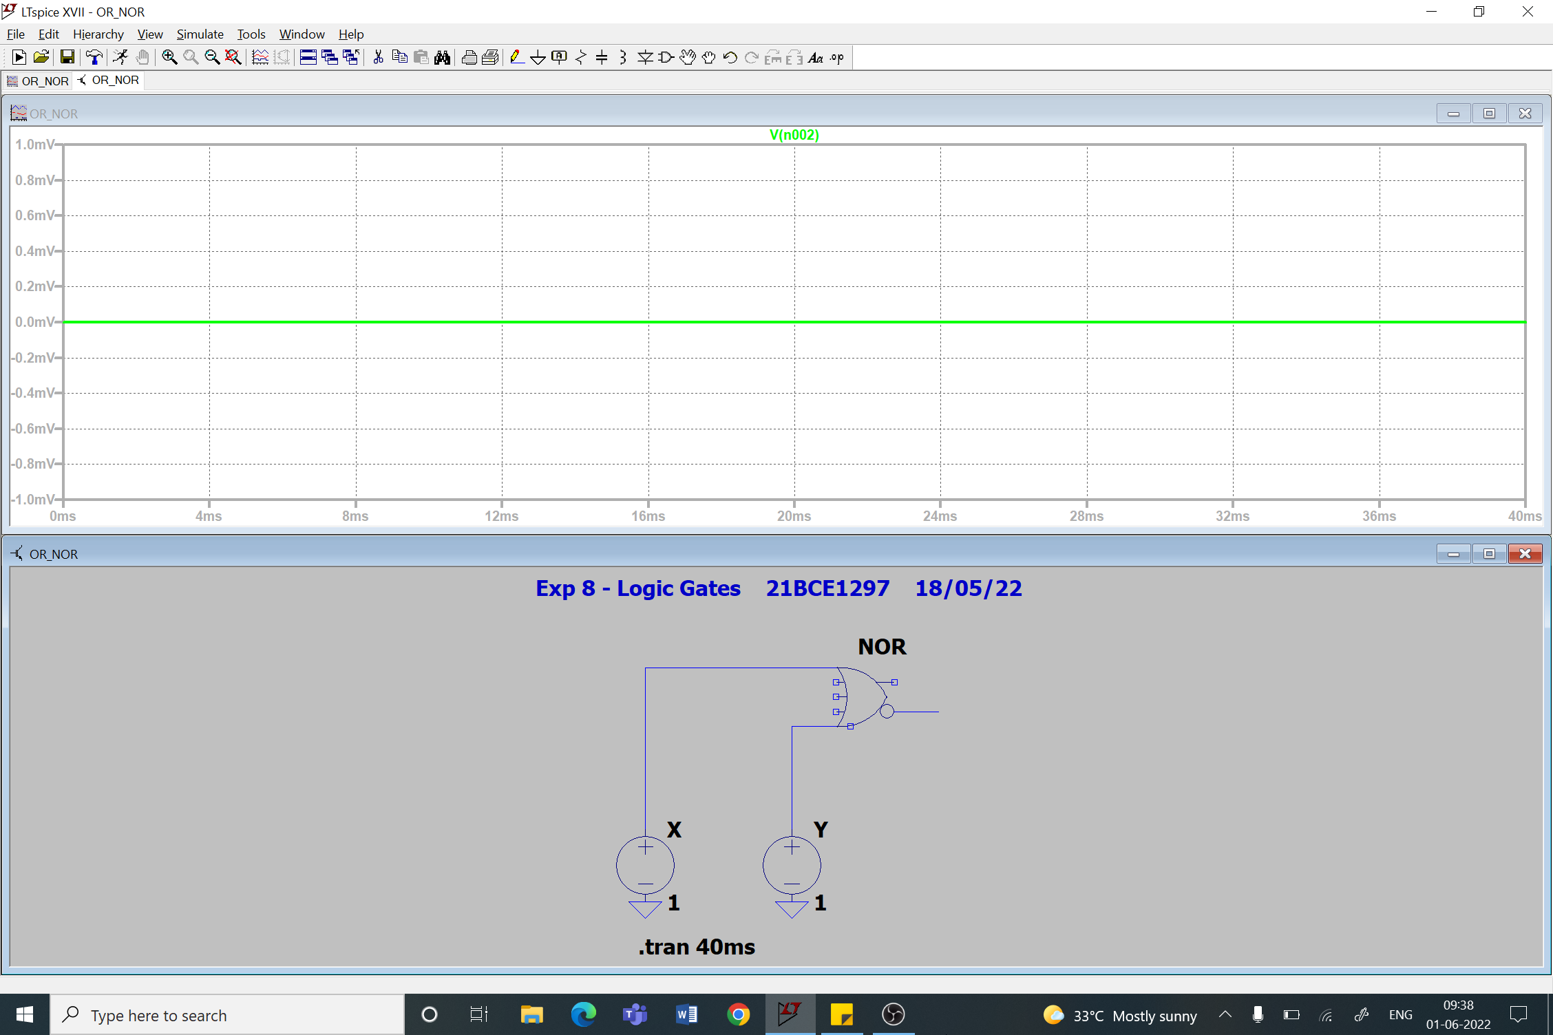

1. **XOR Gate**

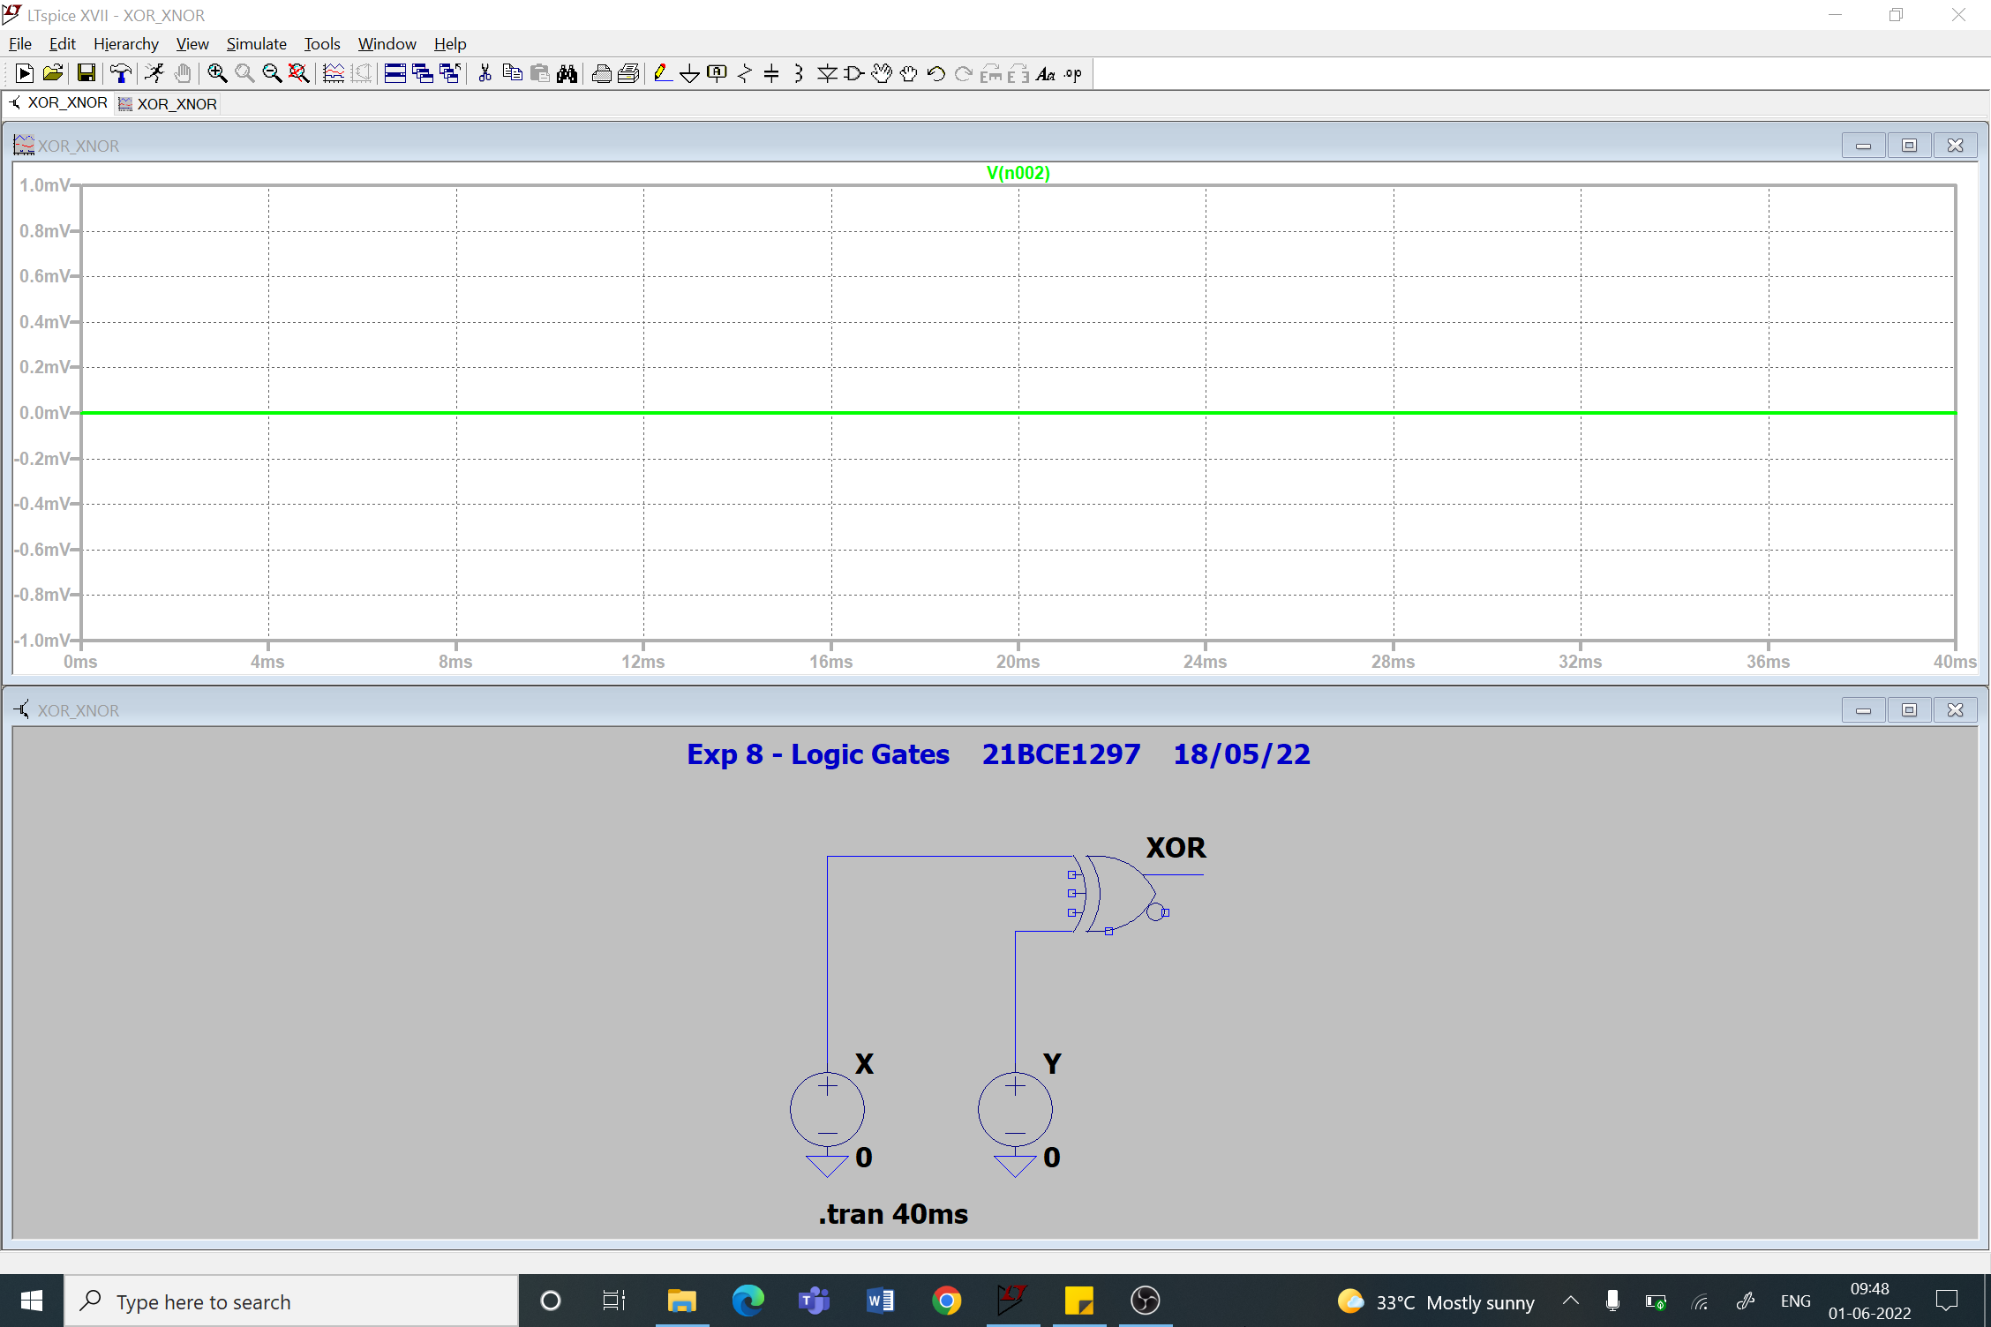

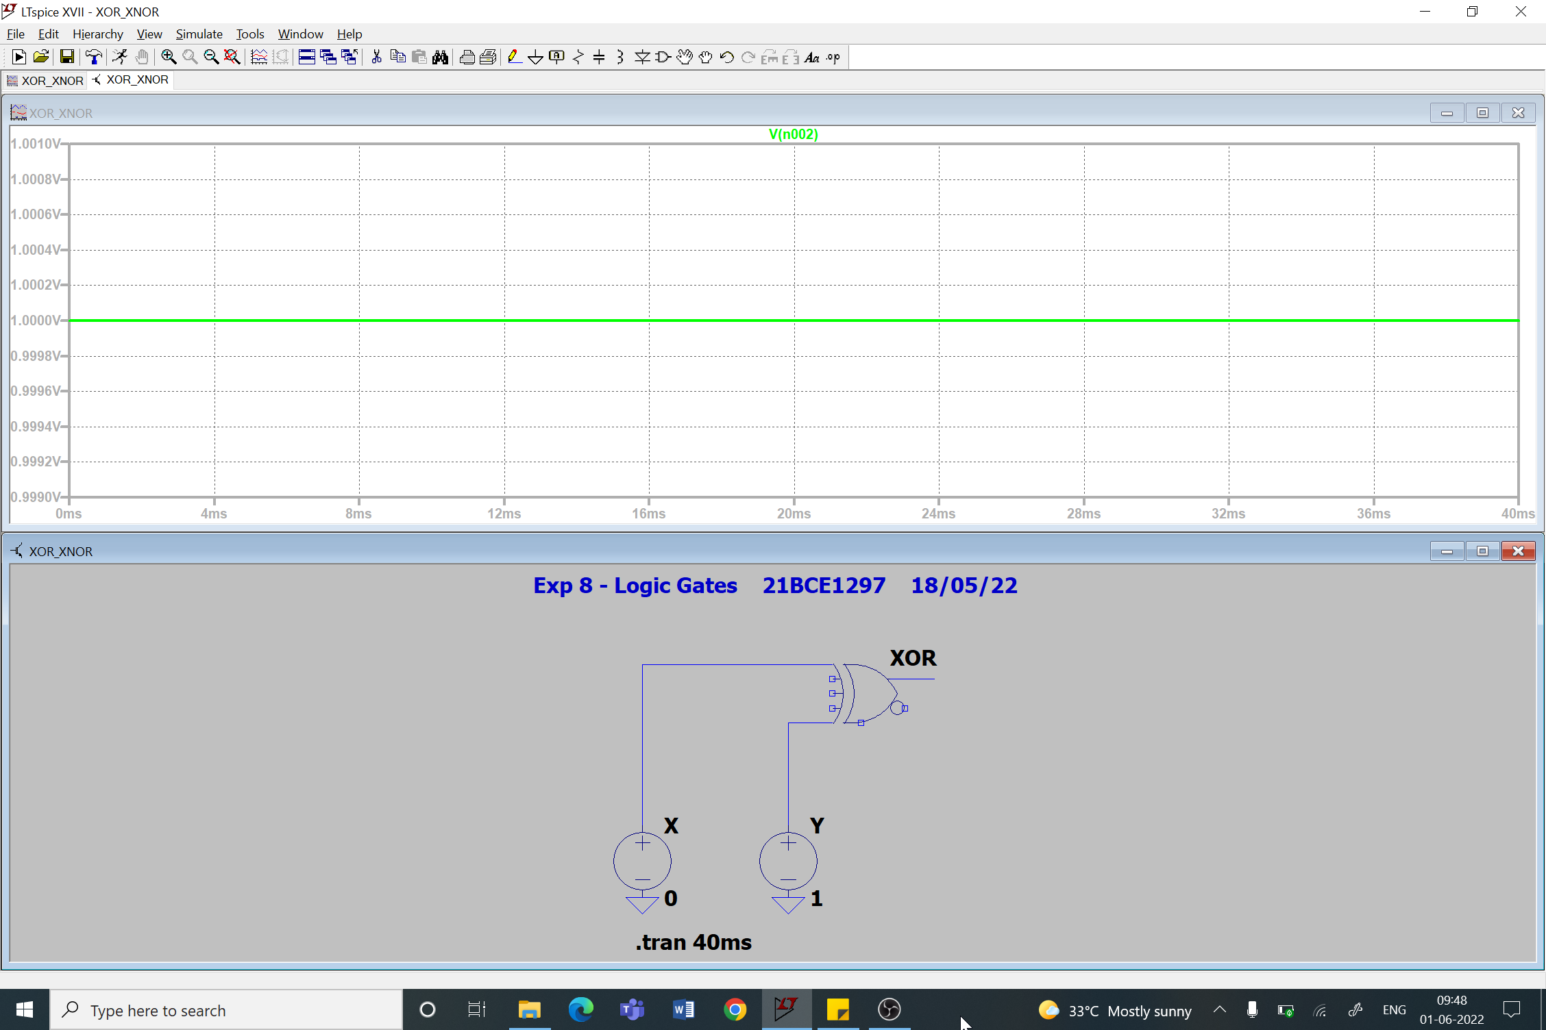

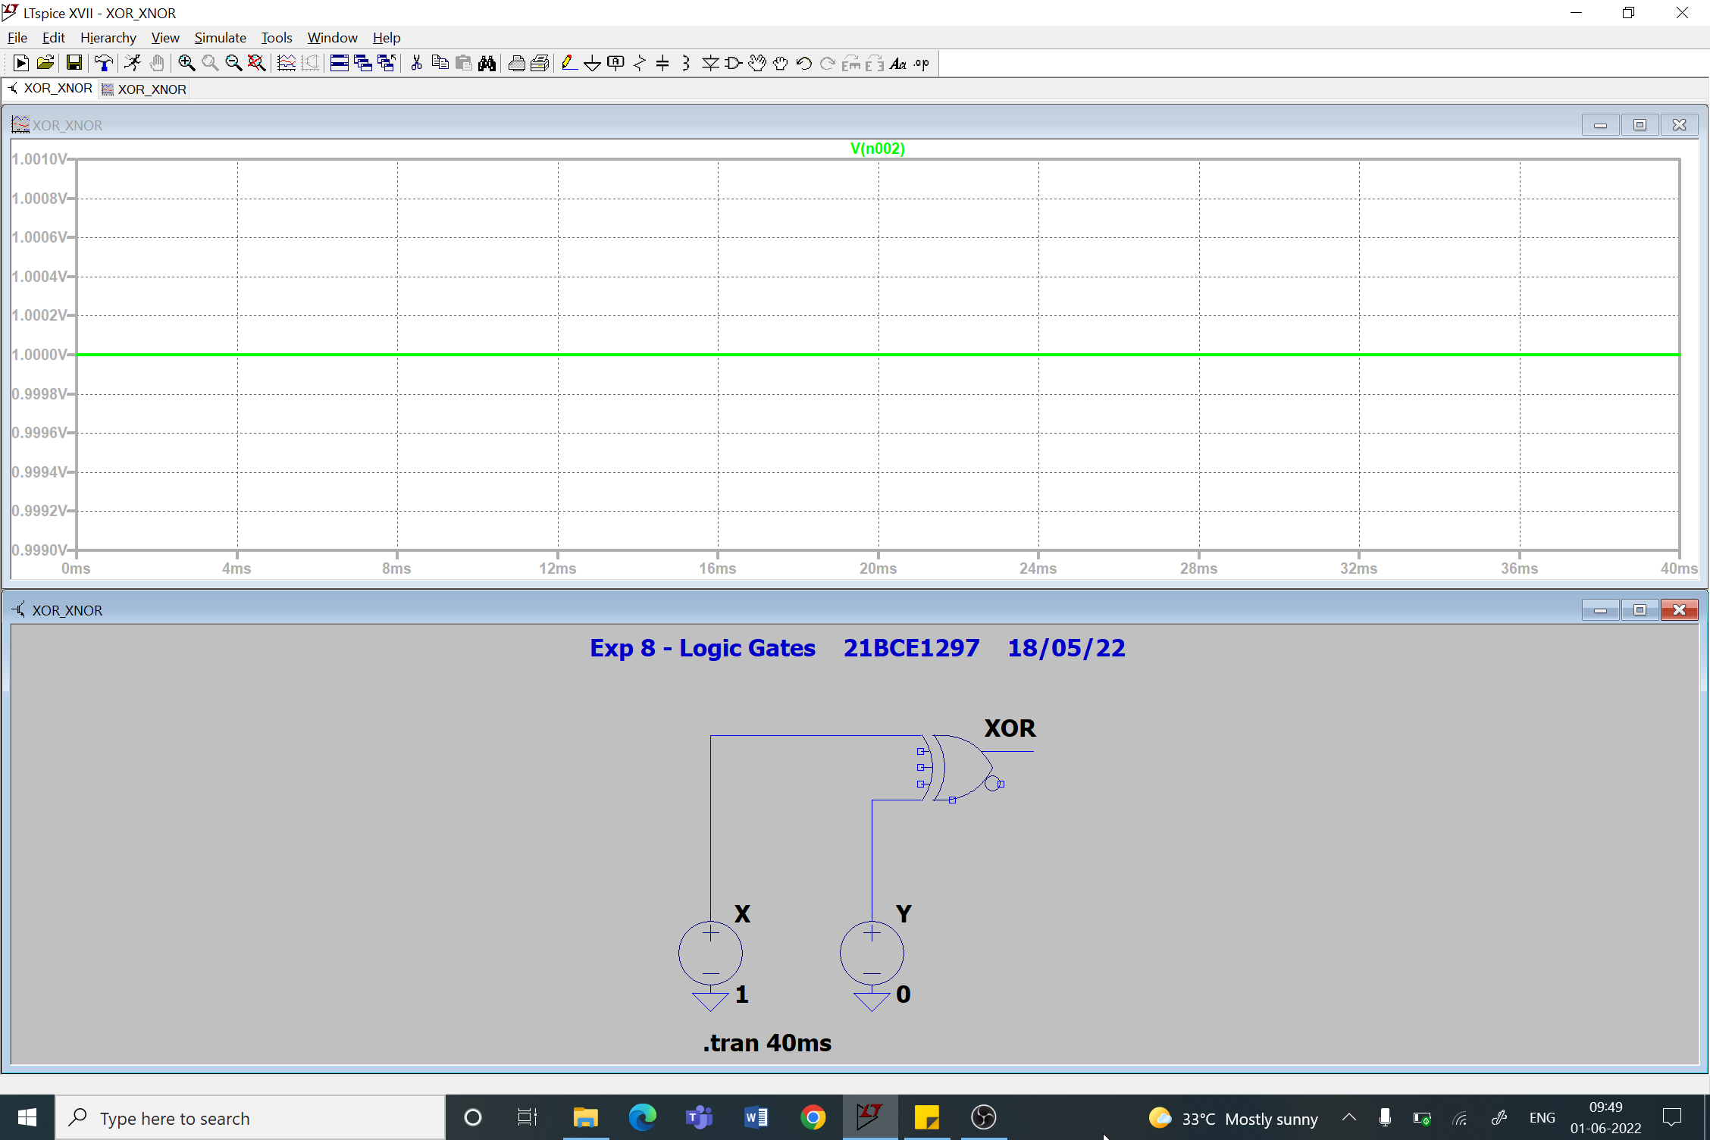

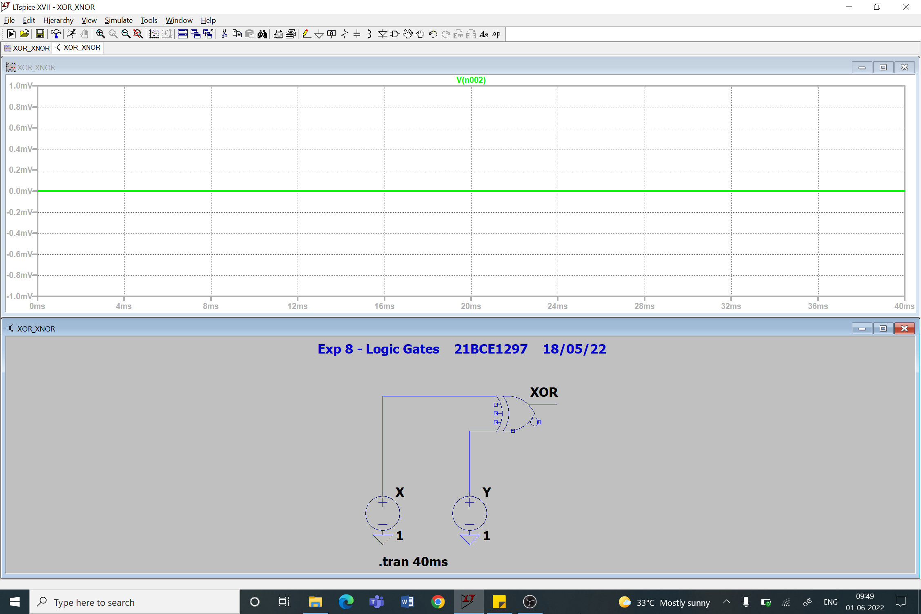

1. **XNOR Gate**

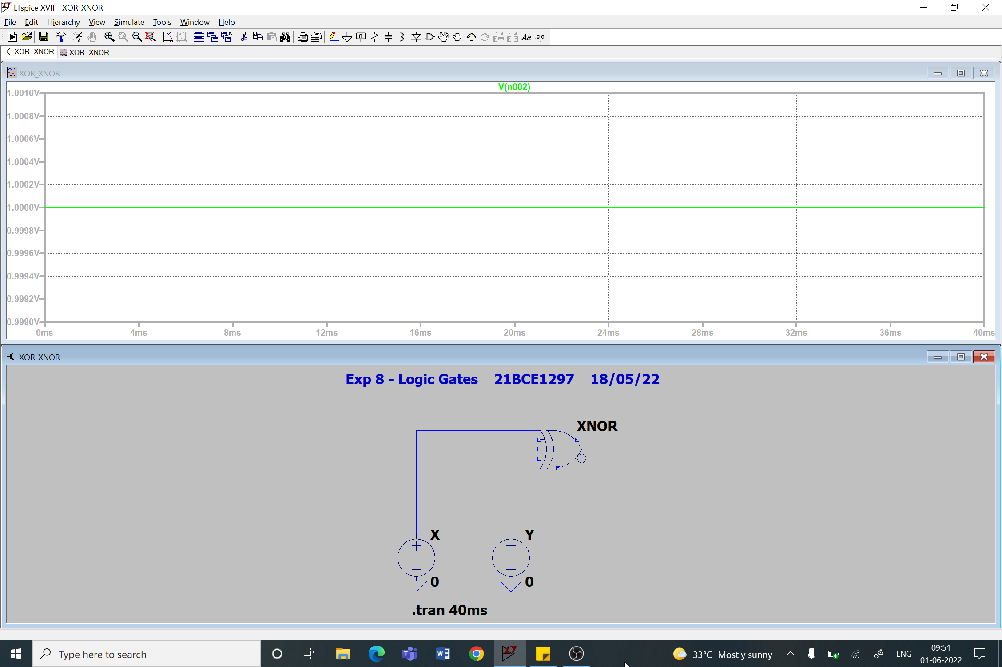

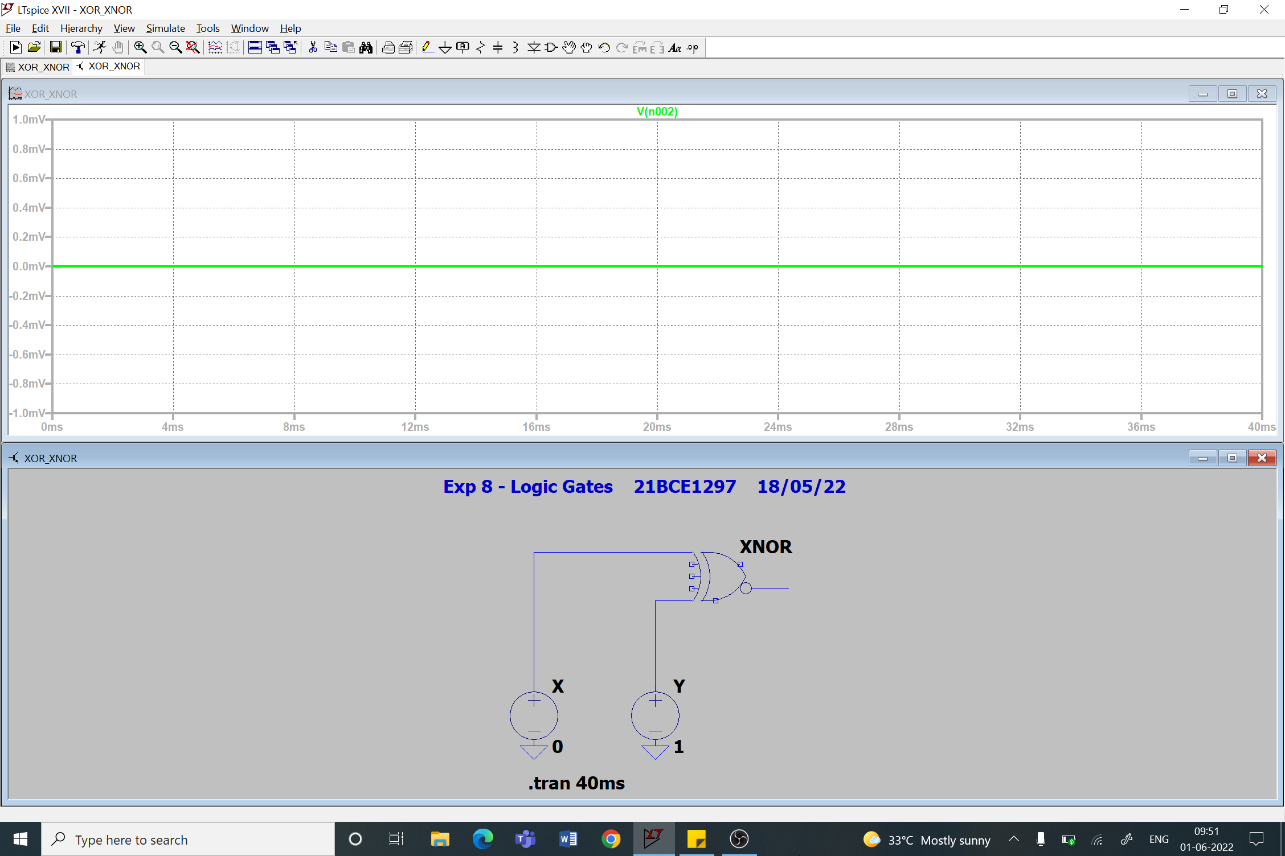

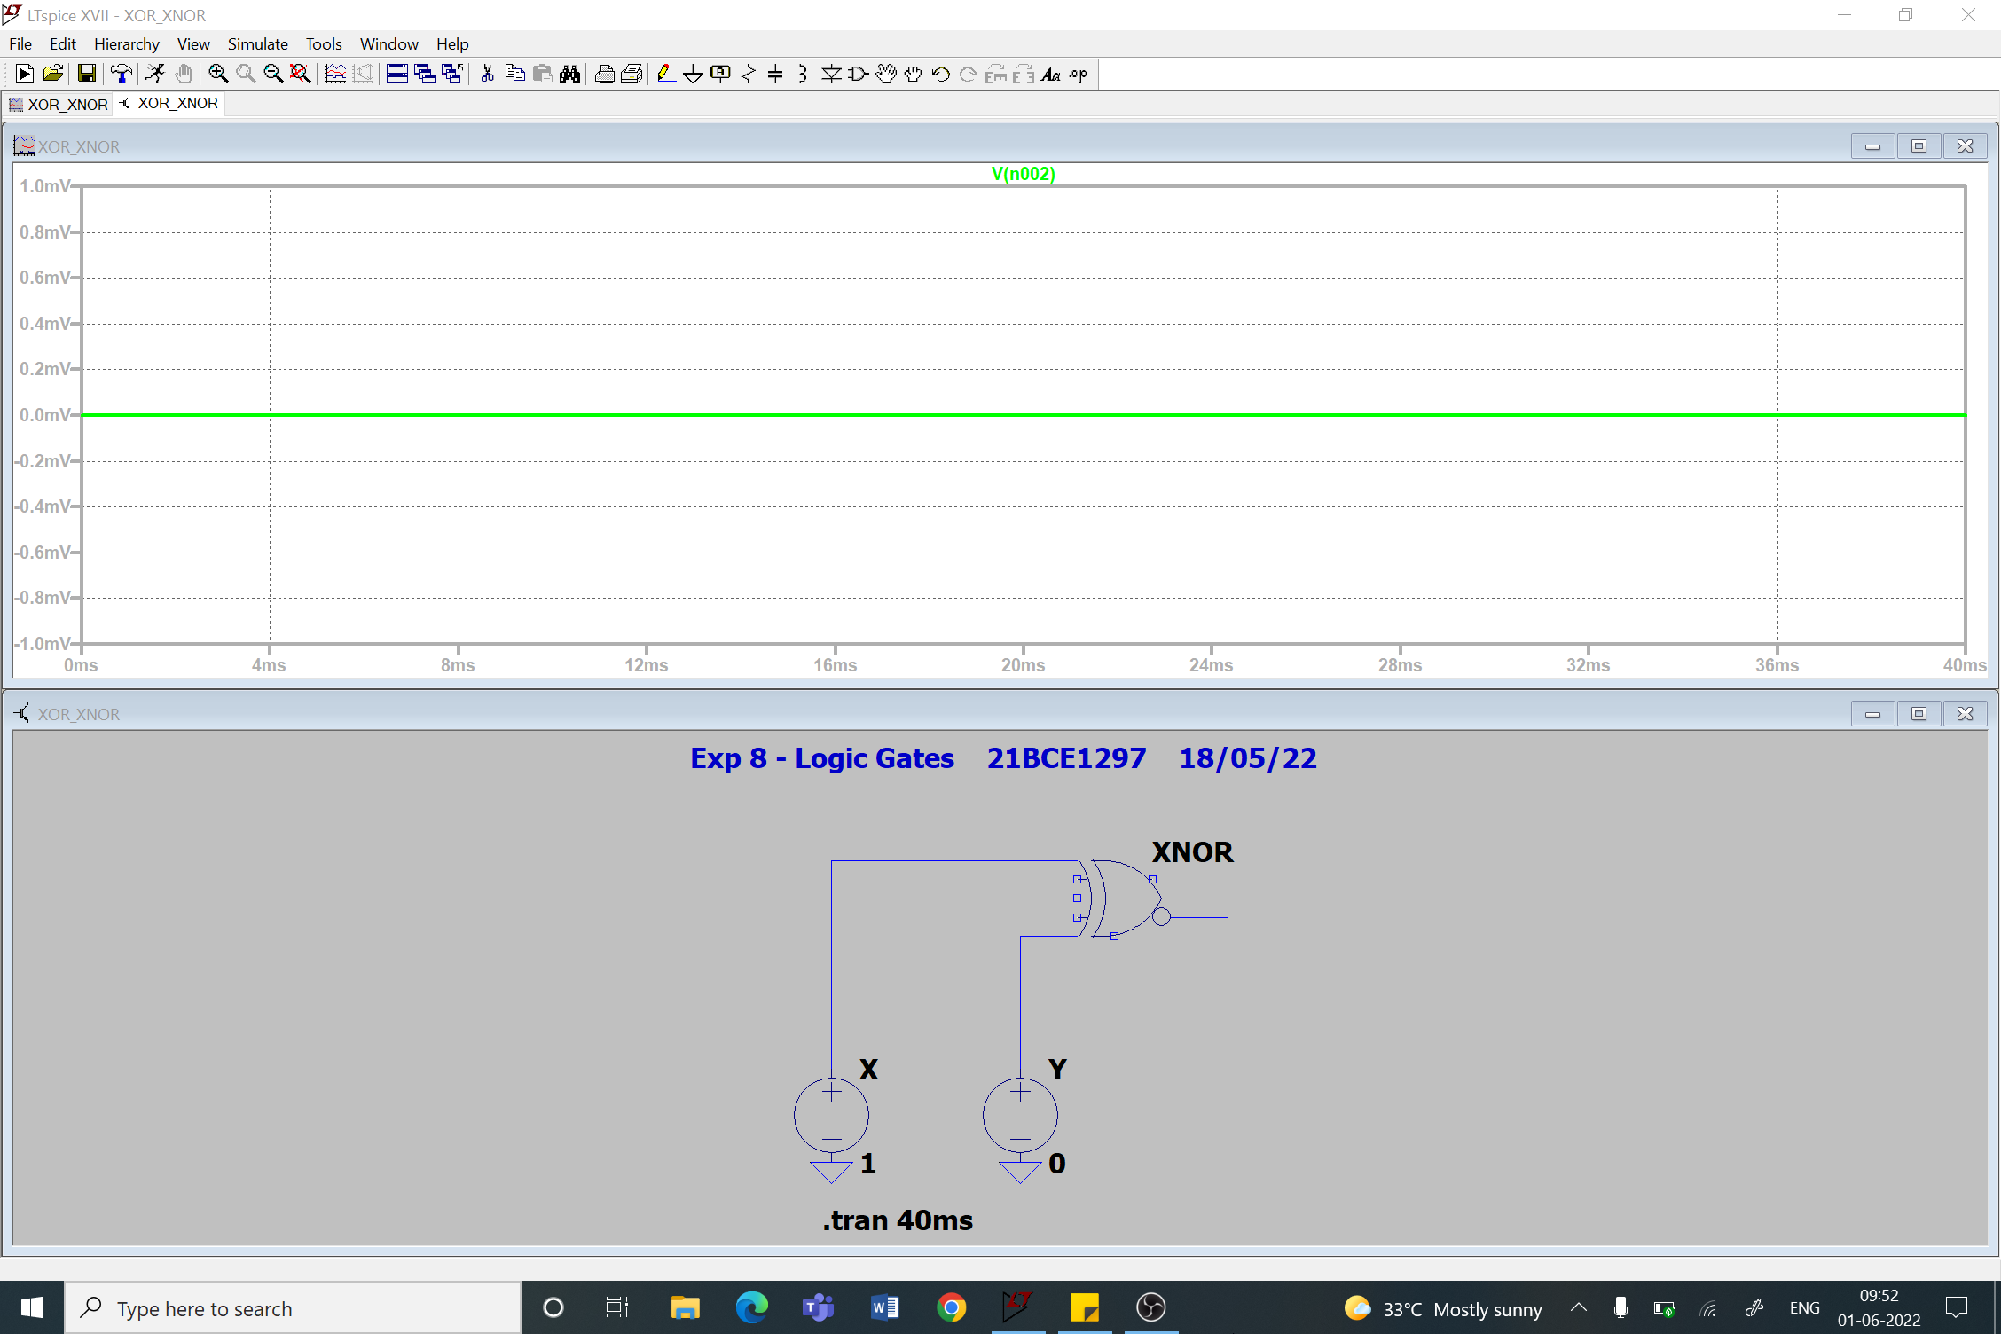

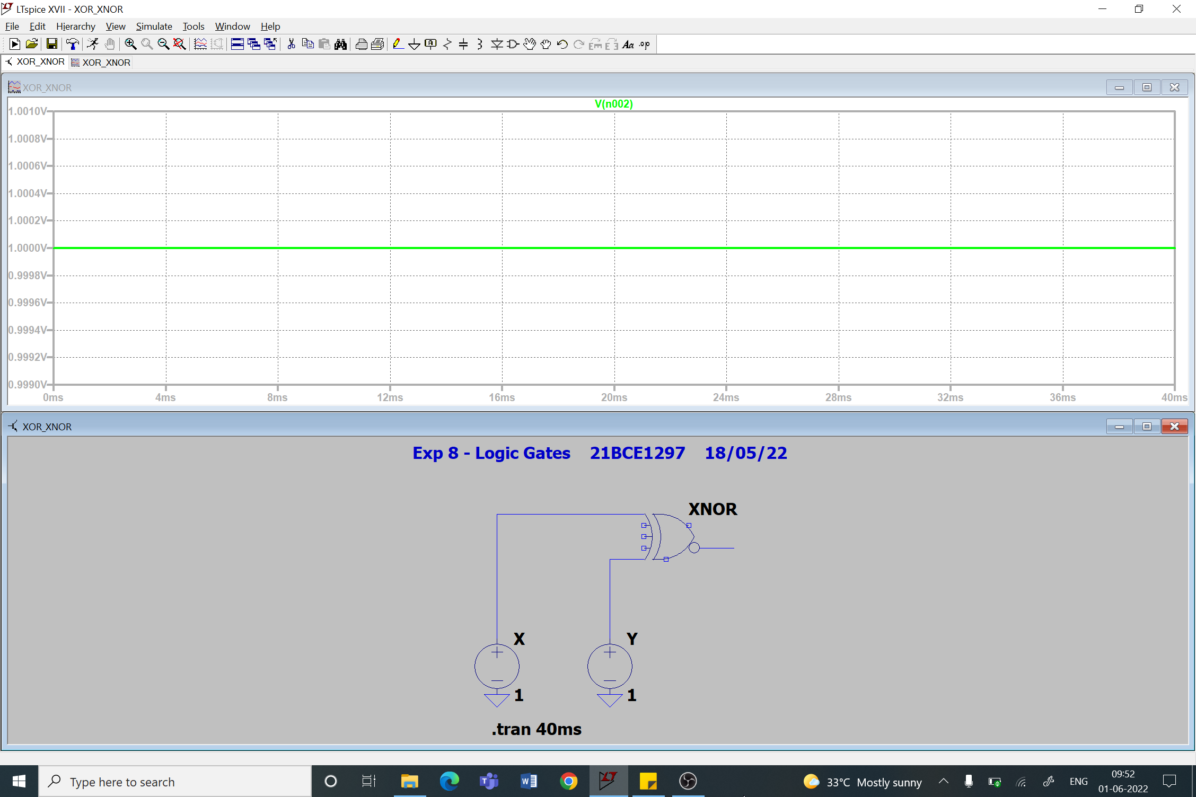

1. **NOT Gate**

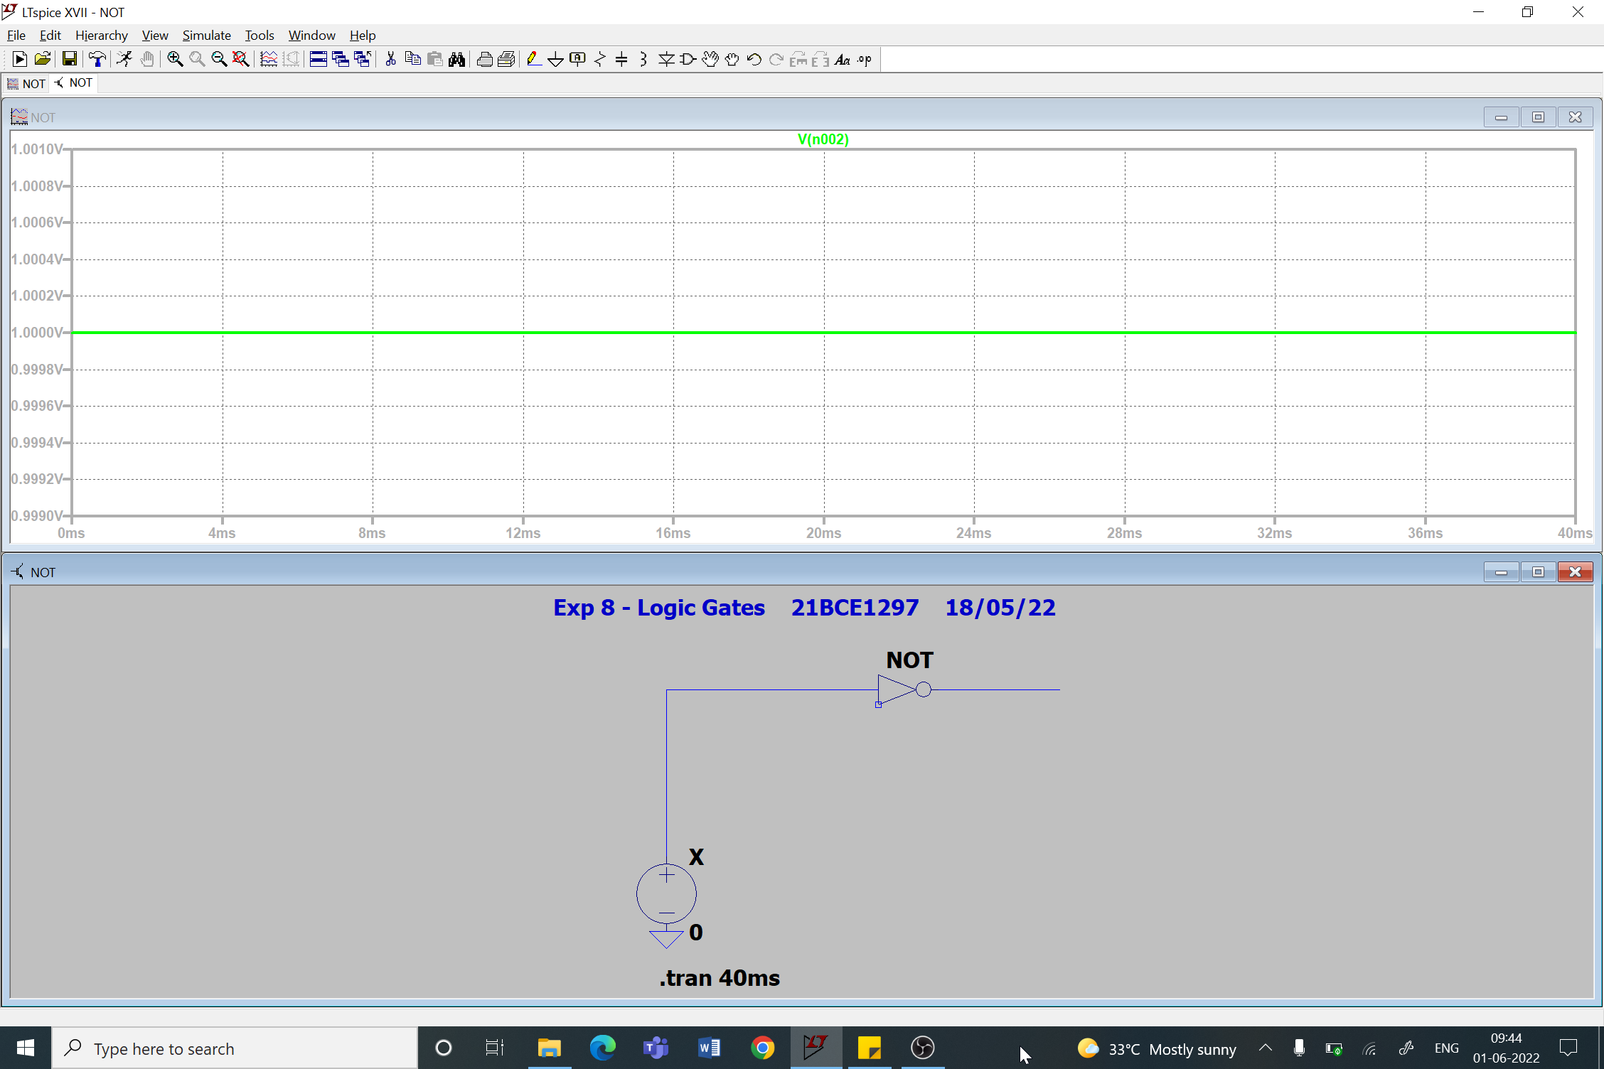

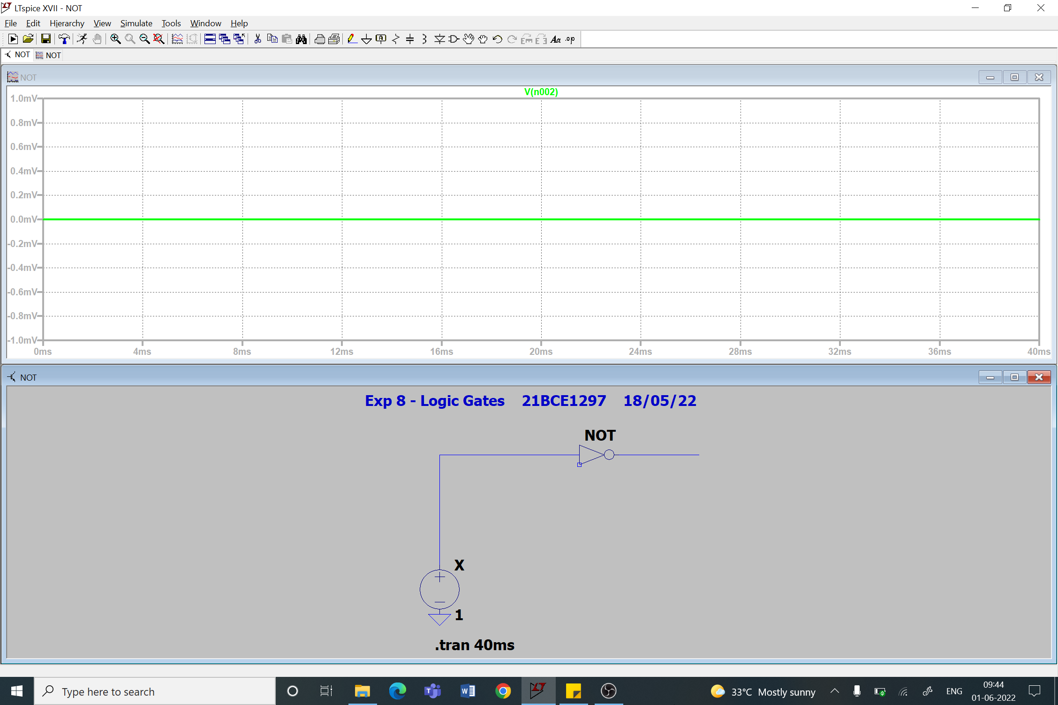

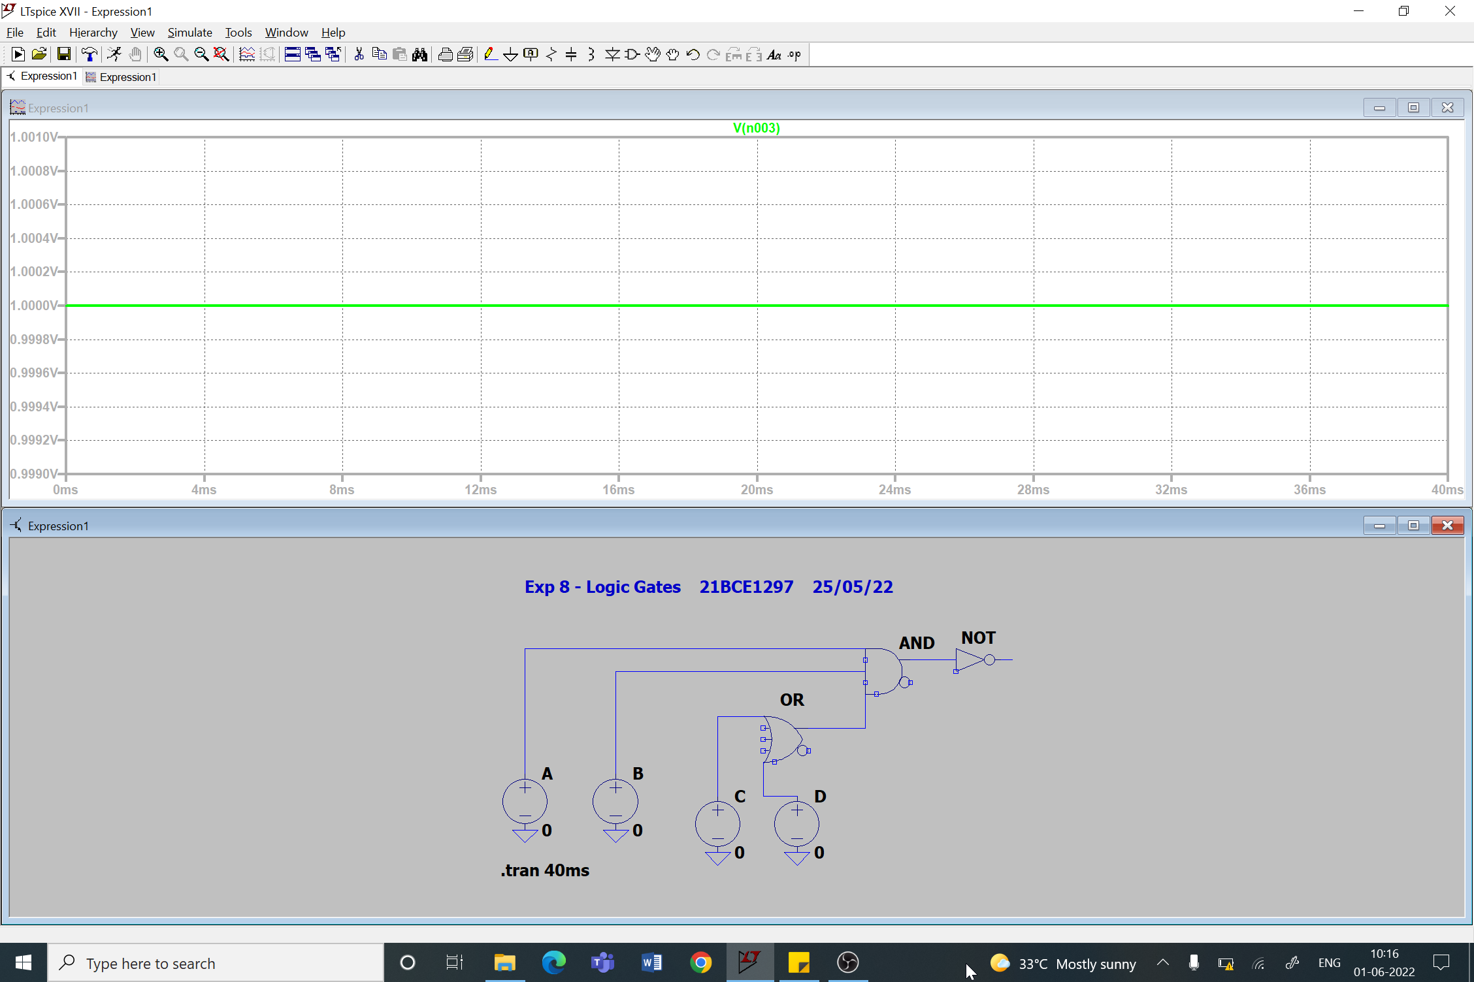

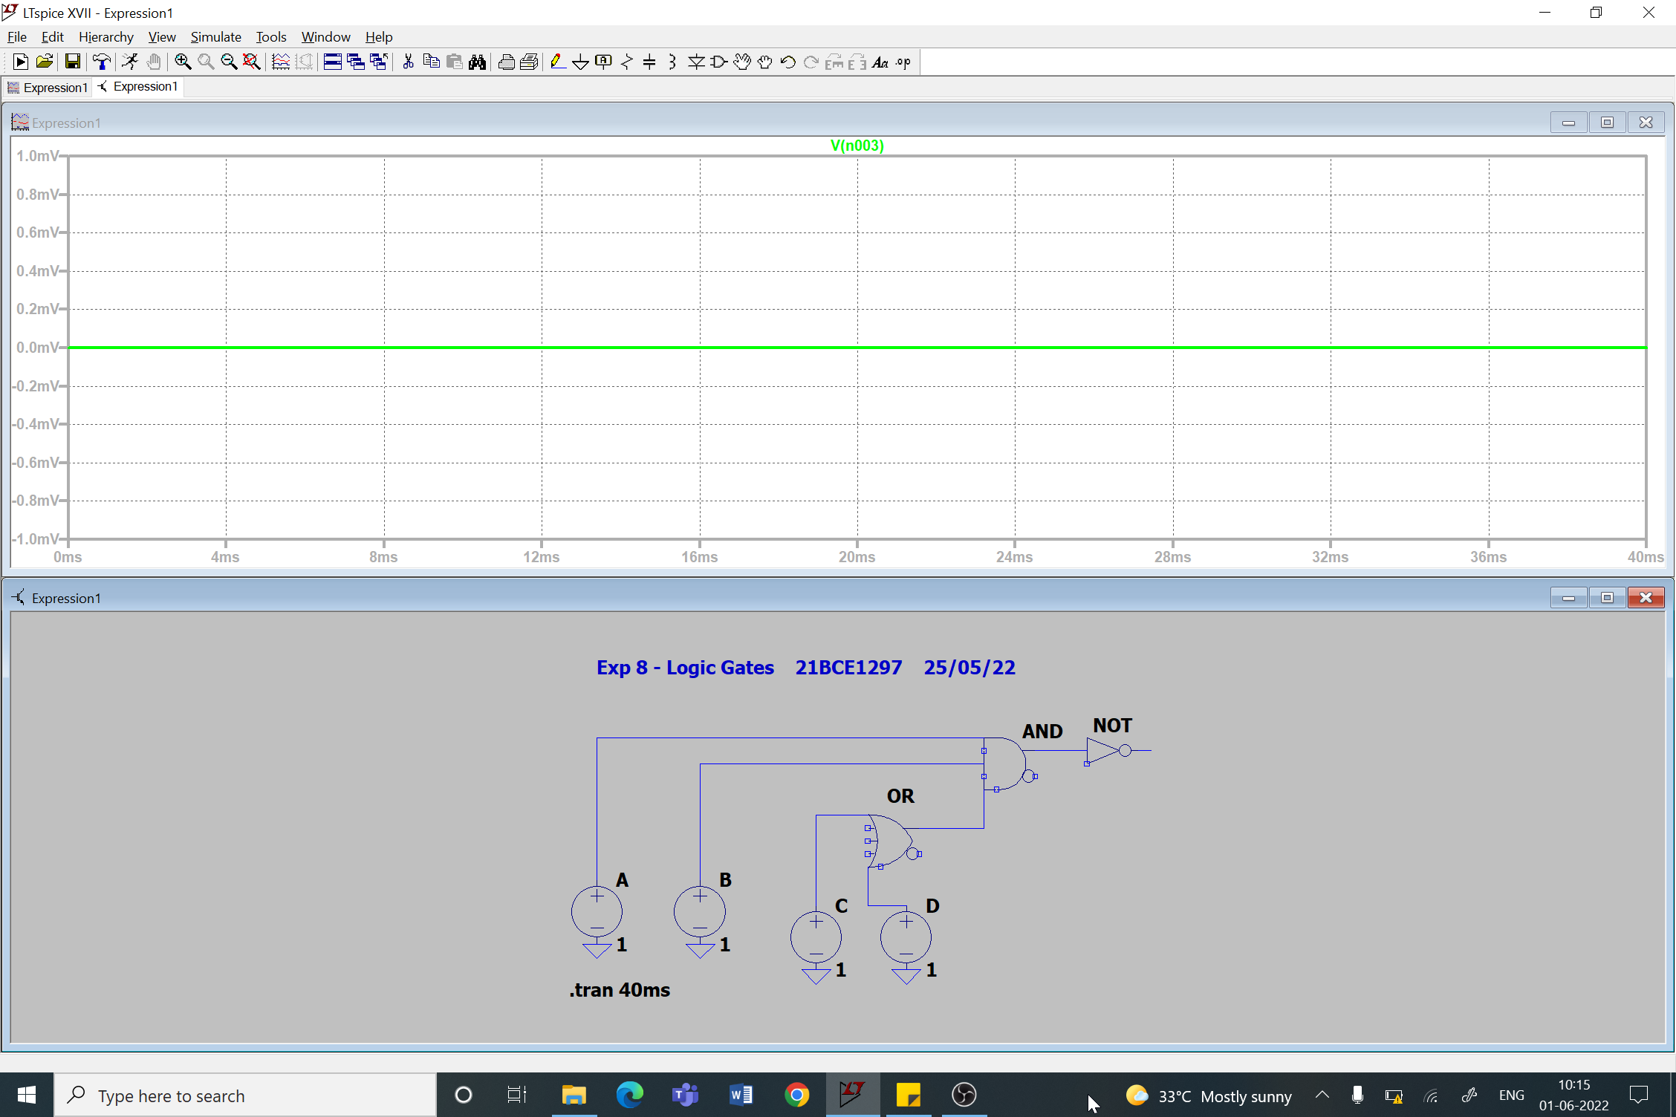

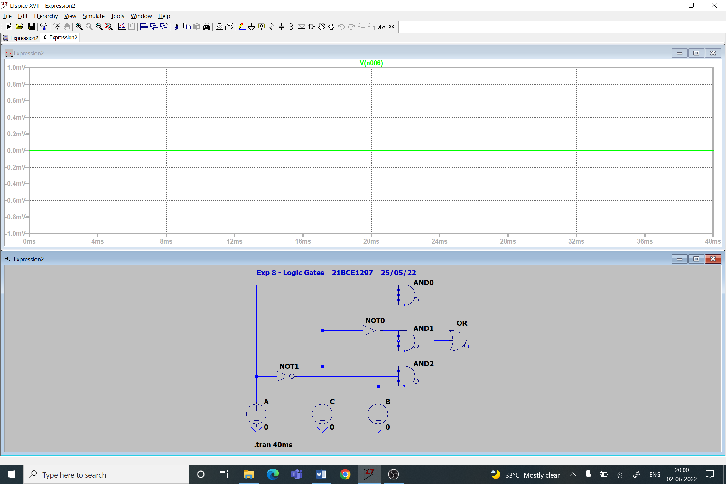

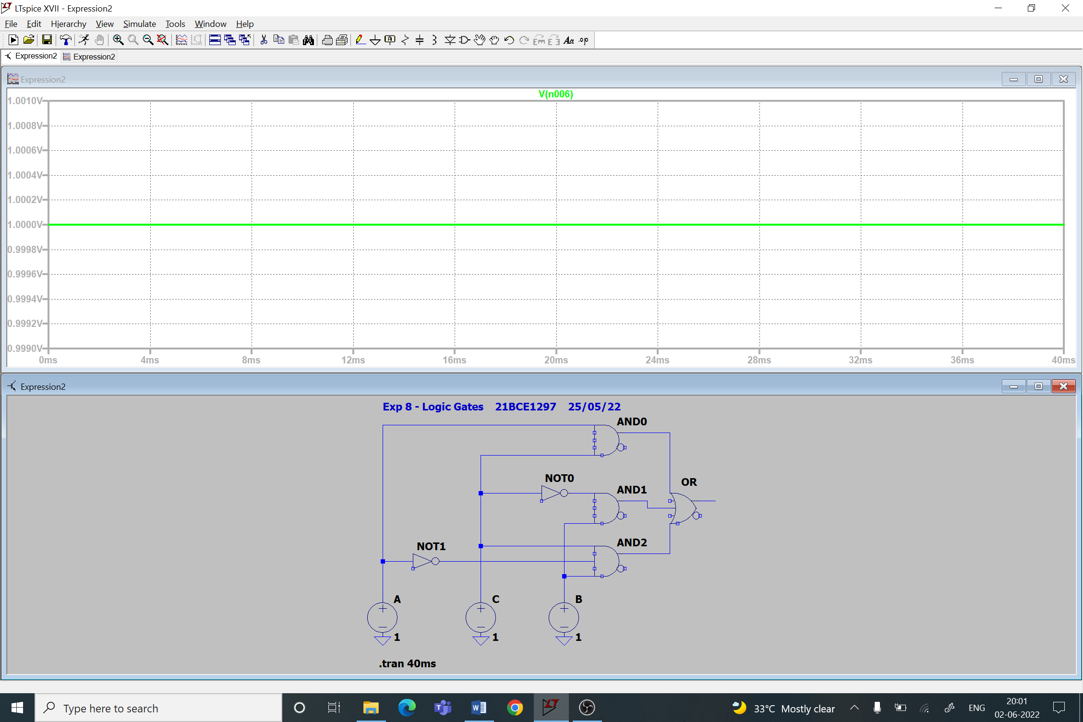



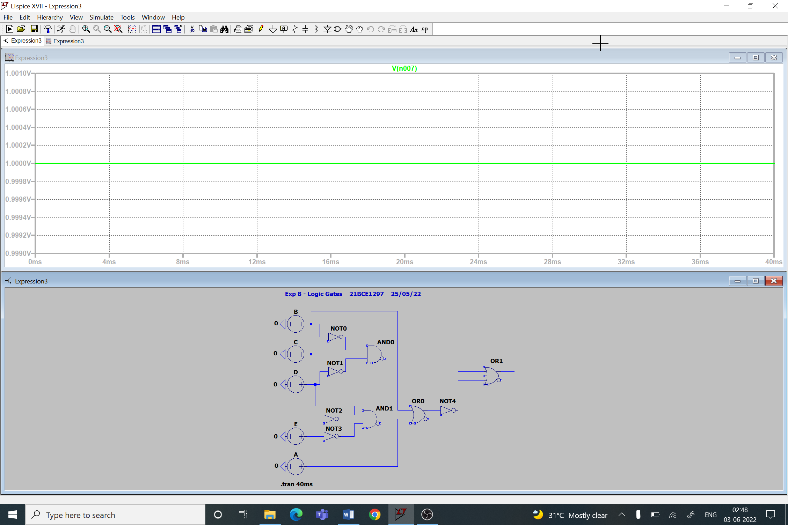

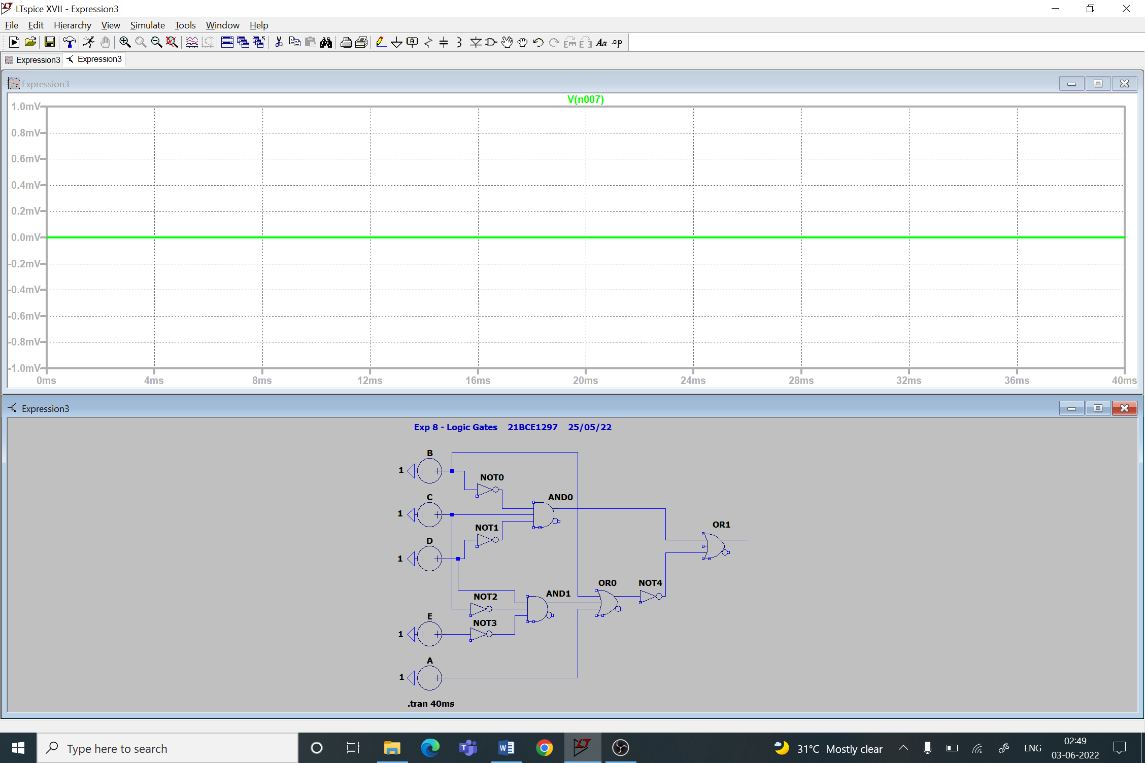

**Conclusion:**

Hence, we can see that the truth table is verified for all Boolean gates and Boolean functions.

**Inferences:**